Fosdem 2025

Table des matières

Saturday 3

FOSDEM 2025 - Program to Learn: The Power of Creative Coding 3

FOSDEM 2025 - Is There Really an SBOM Mandate? 7

FOSDEM 2025 - How Does Heinz Have 80% of a Commodity Market?* – Leveraging Trademarks in Free Software 11

FOSDEM 2025 - Project Lilliput - Looking Back and Ahead 15

FOSDEM 2025 - (Almost) everything I knew about Java performance was wrong 19

FOSDEM 2025 - Stratoshark: Applying the power of Wireshark to System Calls and Logs 22

FOSDEM 2025 - How browsers REALLY load Web pages 25

FOSDEM 2025 - [RESCHEDULED] CERN CTA Service: writing LHC data to tape with opensource software on commodity hardware 35

FOSDEM 2025 - What if Log4Shell were to happen today? 39

FOSDEM 2025 - How Threat Actors Are Weaponizing Your Favorite Open-Source Package Registry 44

Sunday 51

FOSDEM 2025 - GIMP 3 and beyond 51

FOSDEM 2025 - Room changeover & Intro to the Public sector Open Source block 54

FOSDEM 2025 - Making Workspaces Work Together (And Across Borders) 55

FOSDEM 2025 - openDesk and beyond: building the EuroStack 57

FOSDEM 2025 - Digital Identies in disarray 57

FOSDEM 2025 - Accelerating Digital Transformation in Europe: The Role of Digital Public Goods and Open Source Collaboration 59

FOSDEM 2025 - Government Collaboration - Intro 61

FOSDEM 2025 - How is Development and Collaboration Done in Public Sector Open Source Software Projects? Insights from Six Mature Case Studies 62

FOSDEM 2025 - OSOR Handbook on Open Source Software in Public Administration 63

FOSDEM 2025 - Nubo: the French government sovereign cloud 66

FOSDEM 2025 - Community Insights: Best Practices for Open Datasets for LLM training 69

FOSDEM 2025 - The Firefox AI Platform 74

FOSDEM 2025 - The most fun you'll ever have dealing with Firefox crashes 76

FOSDEM 2025 - What’s the (floating) Point of all these data types? A (not so) brief overview of the history and usage of datatypes within the wide world of computation 77

# Saturday

## [FOSDEM 2025 - Program to Learn: The Power of Creative Coding](https://fosdem.org/2025/schedule/event/fosdem-2025-5369-program-to-learn-the-power-of-creative-coding/)

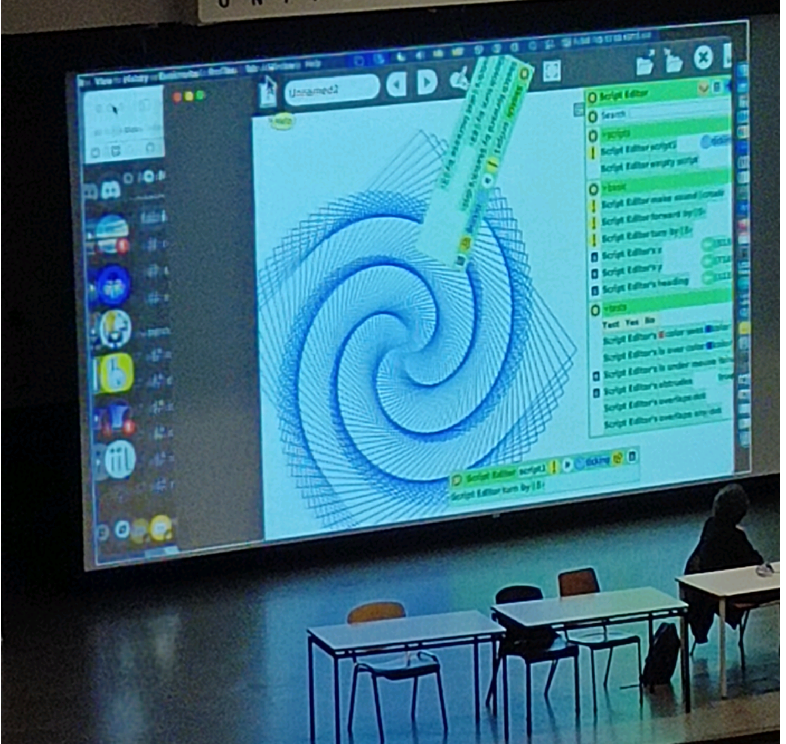

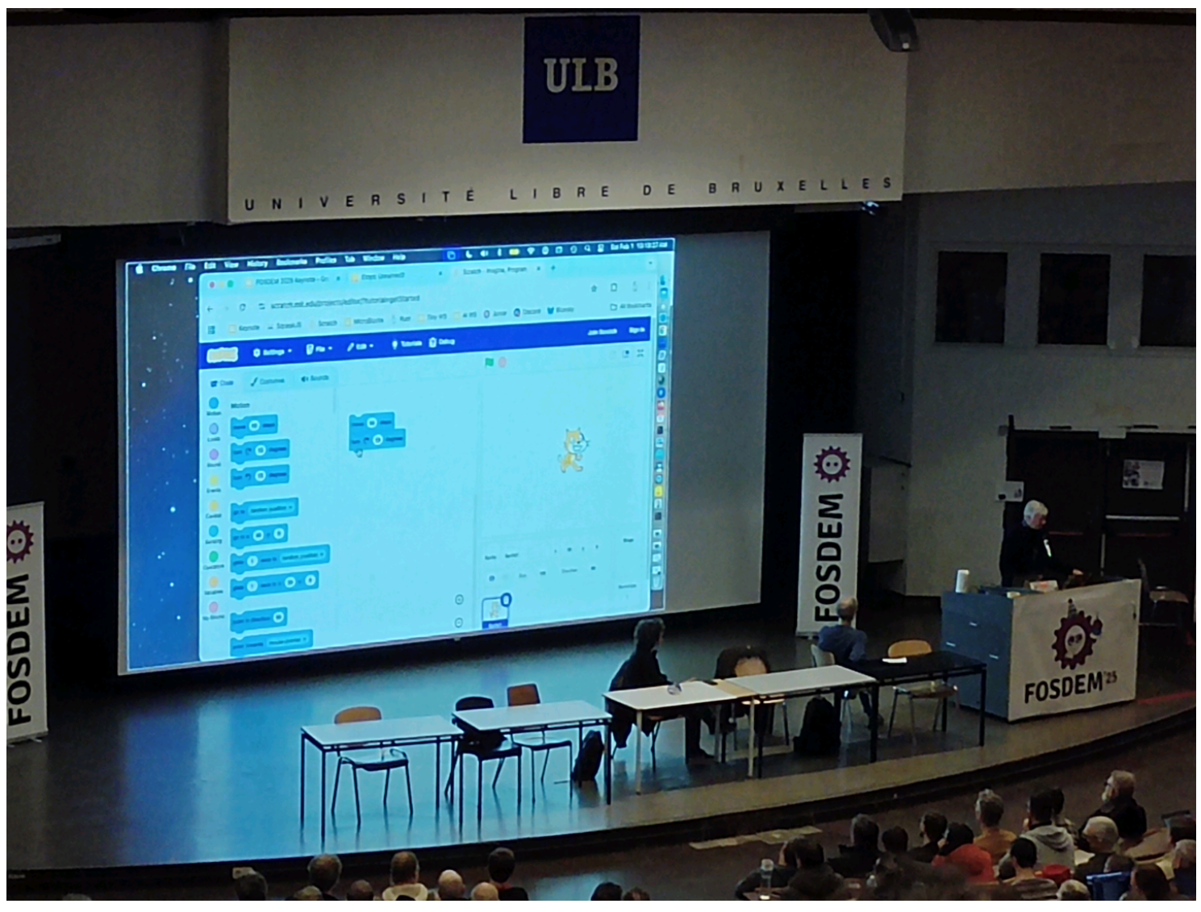

Janson 10h learn to code

* SketchJs (?)
* scratch
* Microblocks

from generating model/shape/sound to print/ even sewing machine/visualise

Build something

## [FOSDEM 2025 - Is There Really an SBOM Mandate?](https://fosdem.org/2025/schedule/event/fosdem-2025-6155-is-there-really-an-sbom-mandate-/)

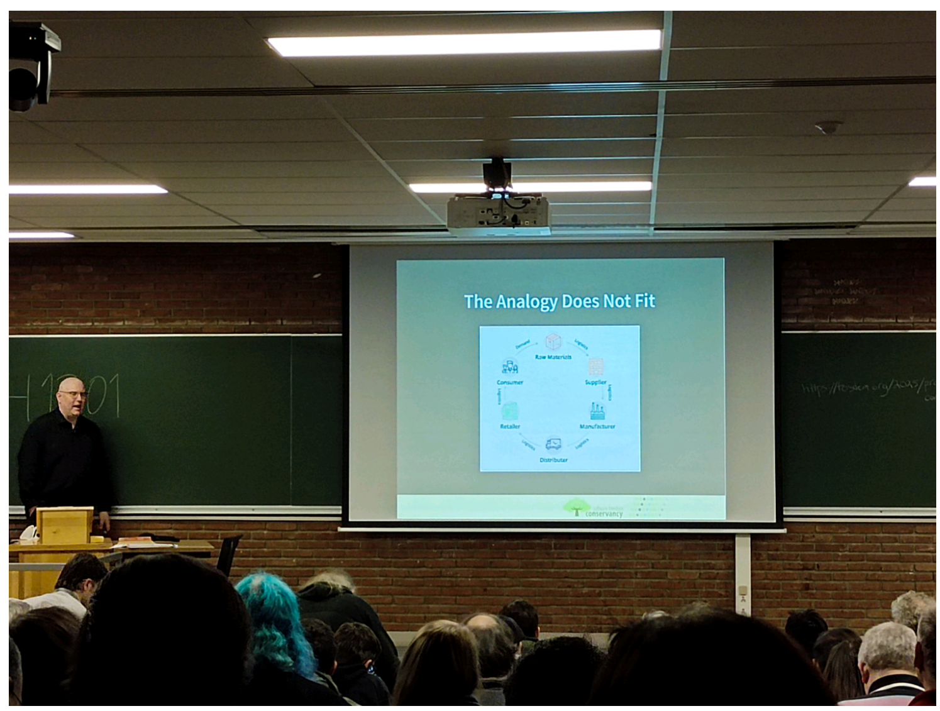

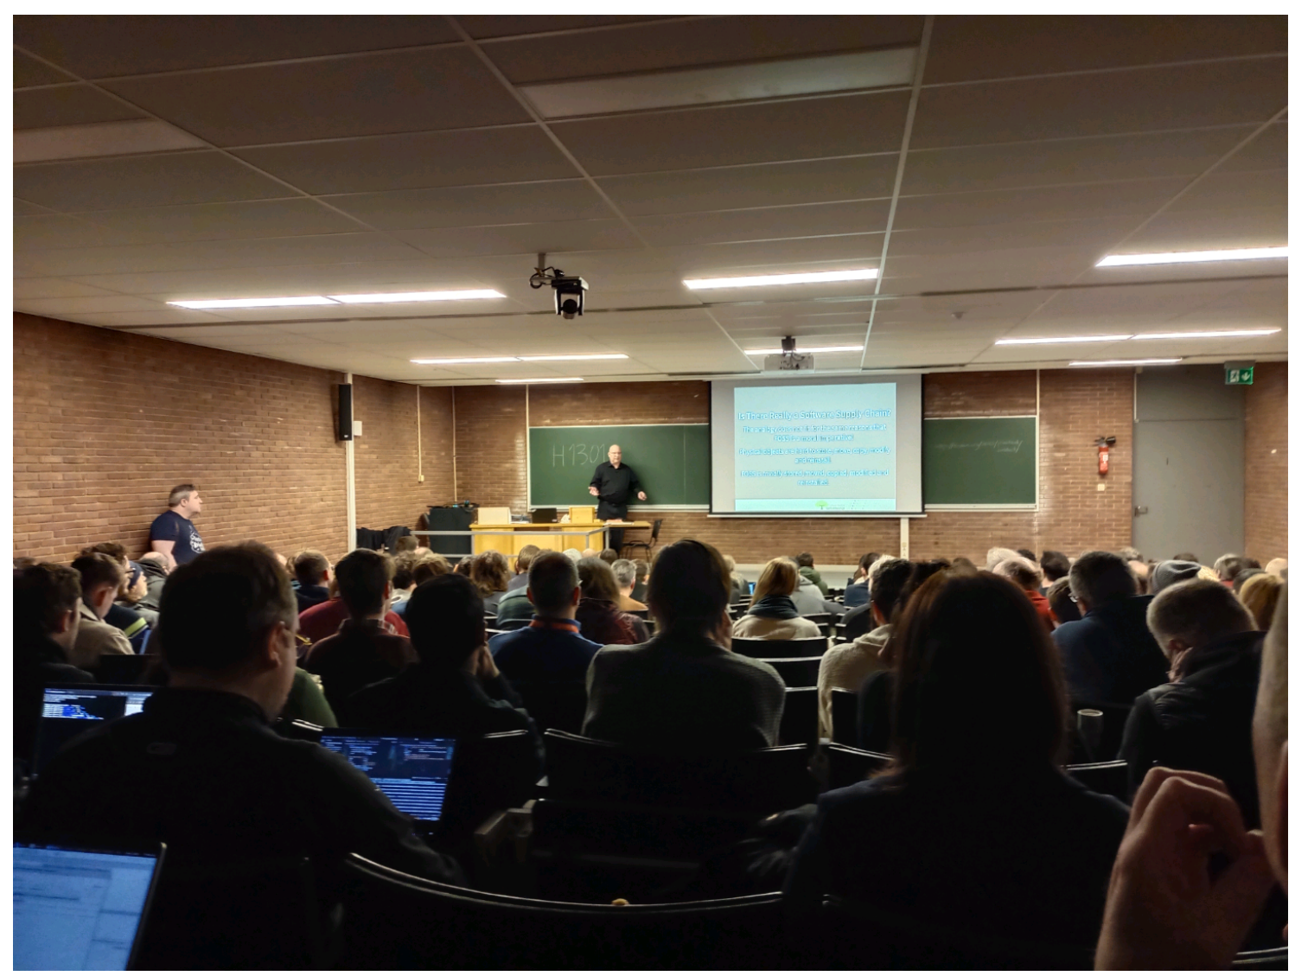

H1301 11h00 sbom mandate in foss ?

Réalité de la supply chain (?) a-t-elle vraiment du sens au sens matériel/bien possédé ?

Pourquoi : assurer la traçabilité (?) fiabilité (?) d'un soft

Contradictoire avec le principe d’Open source software qui est partagé, modifié et réutilisé ?

Donc qu'est-ce que SBOM pour foss, comment pourrait-on le définir ? Est-ce nécessaire pour foss ?

Le terme supply chain est inhérent aux industries sans prendre en compte l'utilisateur, le terme de supply chain est peut-être galvaudé/utilisé à tort ?

## [FOSDEM 2025 - How Does Heinz Have 80% of a Commodity Market?* – Leveraging Trademarks in Free Software](https://fosdem.org/2025/schedule/event/fosdem-2025-6544-how-does-heinz-have-80-of-a-commodity-market-leveraging-trademarks-in-free-software/)

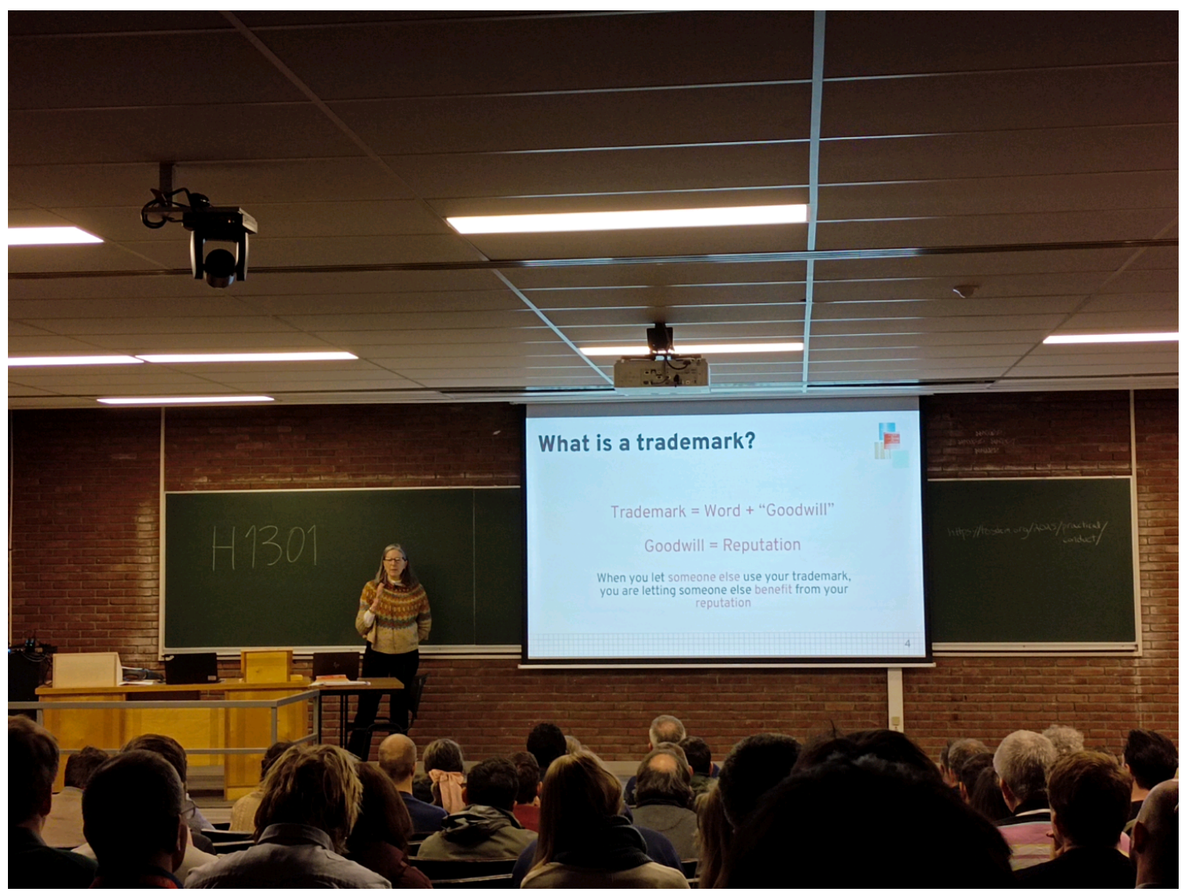

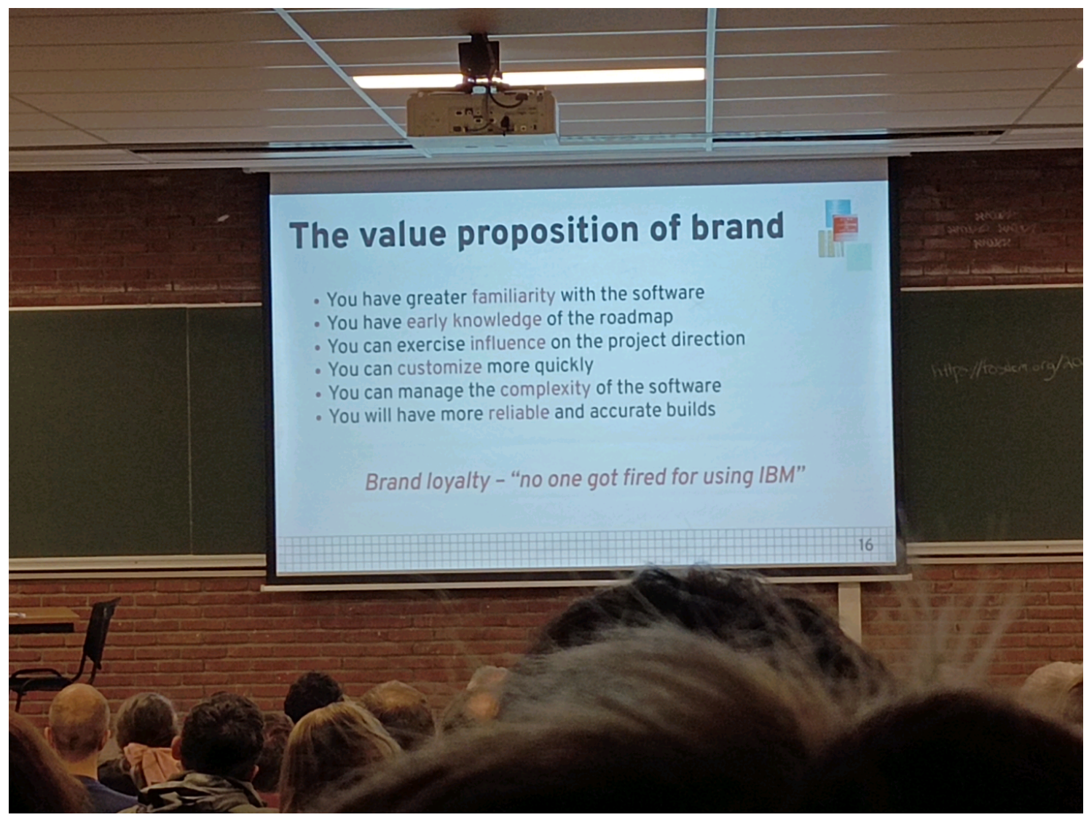

11h30 leveraging trademarks (Chestek)

Trademark ? = Mot + "bonne volonté"

-> réputation

-> comparaison

Bénéfice d'utiliser un trademark > utilisation de la réputation (consciente ou inconsciente)

But : Protection contre la confusion

Endorsement, relation dans les 2 sens

Trademark (protéger l'utilisateur)=/=patent (protéger le concepteur)

Le trademark serait le seul concept propriétaire qui fait sens pour le foss

Commodity

Trademark ne rend pas les choses meilleurs mais définit l'attente des utilisateurs/ qu'est ce qui est considéré bon /bien /mieux dans leur tête

Le gain ? Le fait de faire connaître et simplifier l'utilisation ou réutilisation, la loyauté

La perte d'un trademark? La perte de la "définition" par l'incompréhension/utilisation à tort en masse/le fait de permettre cette confusion

## [FOSDEM 2025 - Project Lilliput - Looking Back and Ahead](https://fosdem.org/2025/schedule/event/fosdem-2025-5526-project-lilliput-looking-back-and-ahead/)

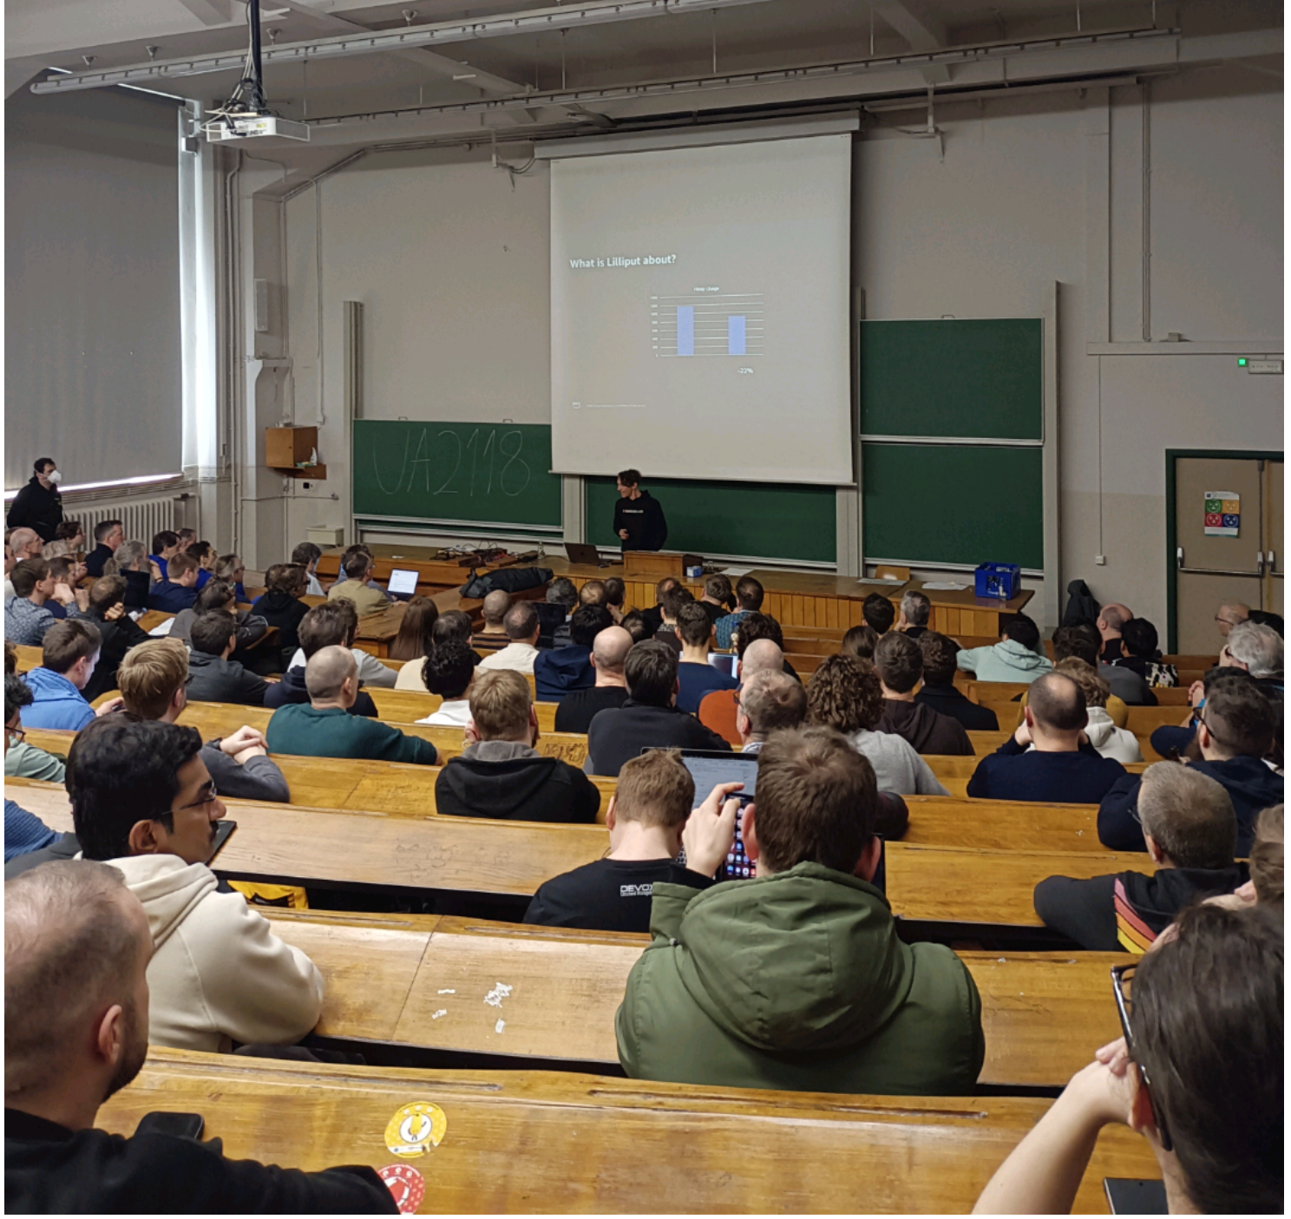

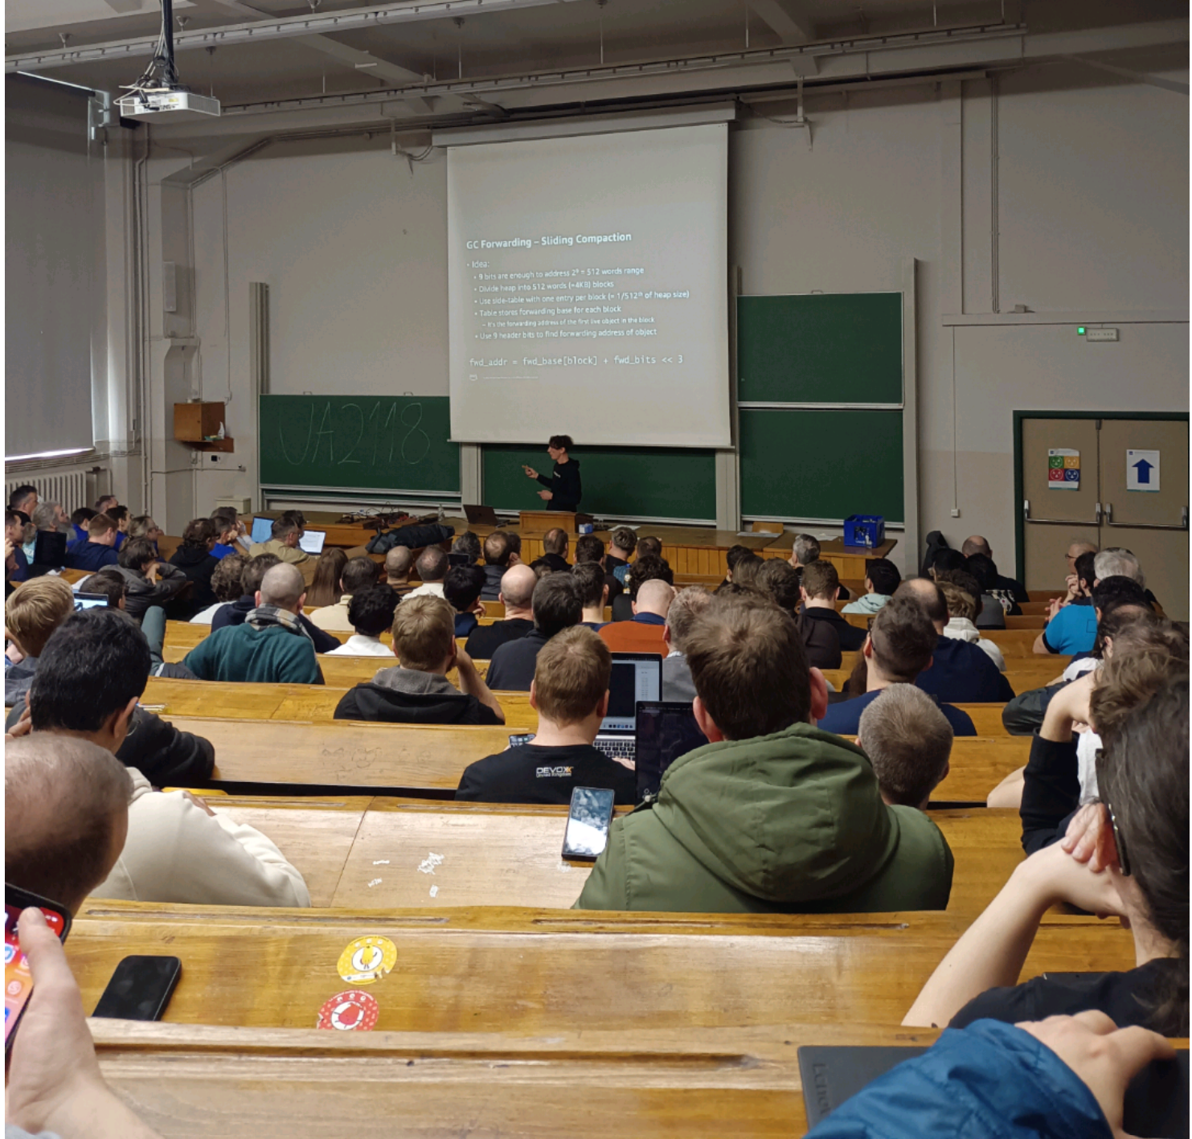

12h00 UA2.118 Henriot Free java Lilliput

Reduce memory footprint of java app

Depuis 2014 (jdk 14)

Réduction de 20%

En compressant et évitant l'espace inutilisé dans l'encodage ??

## [FOSDEM 2025 - (Almost) everything I knew about Java performance was wrong](https://fosdem.org/2025/schedule/event/fosdem-2025-4987--almost-everything-i-knew-about-java-performance-was-wrong/)

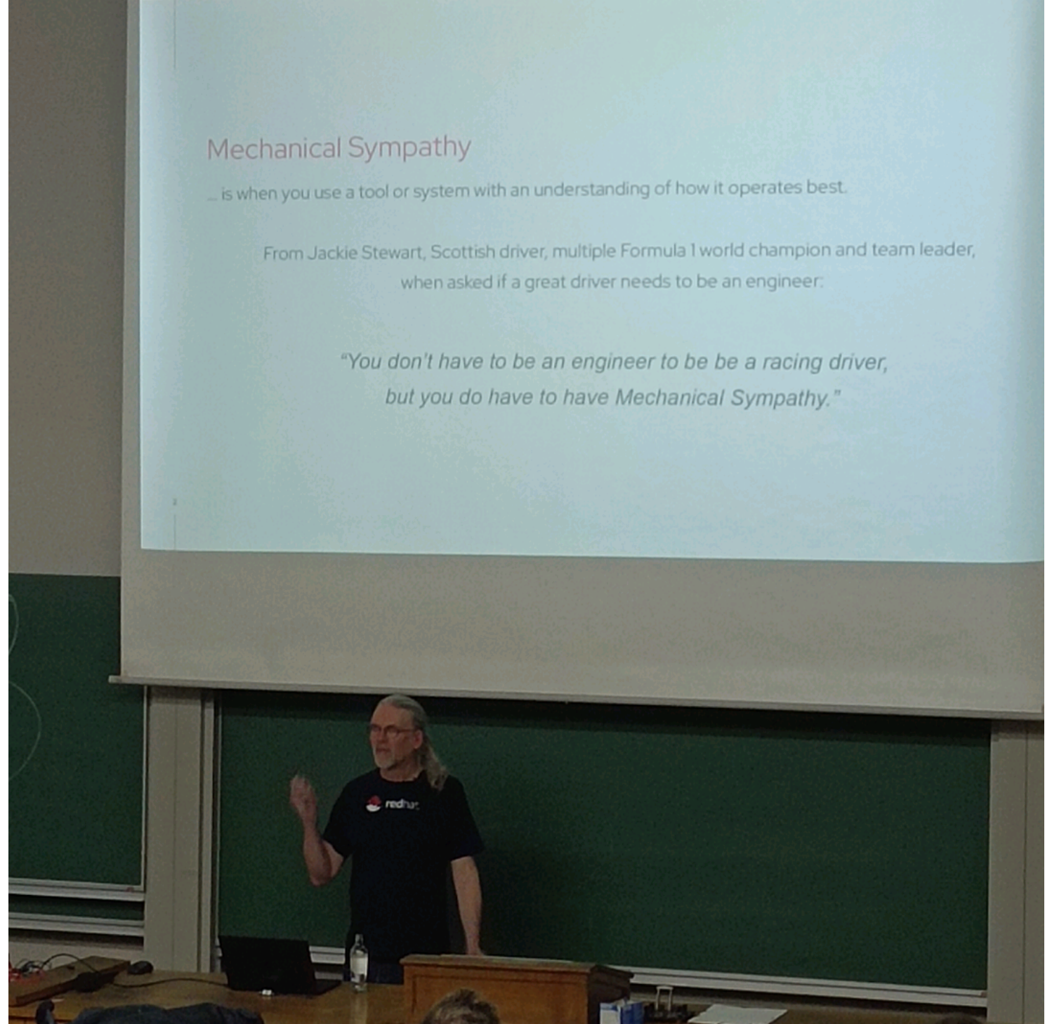

12h30 Java perf

Consommation de puissance deux plus de puissance nécessaire pour chaque action, on récupère un résultat 1fois /2 d'où 2x plus de puissance nécessaire (cpu 4ghz serveur 2ghz?)

Améliorer la perf ? Plus vite ou plus vaste, on ne peut pas aller plus vite donc

Prédiction de la machine sur ce qui va être utiliser pour économiser

Clock cycle => latence d'une opération (diff en fonction du type de l'opération)

Où cela peut faire défaut ? Cache "scopevalie cache" qui permet la prédication et la diminution du délai

Hashed interface checkcast

## [FOSDEM 2025 - Stratoshark: Applying the power of Wireshark to System Calls and Logs](https://fosdem.org/2025/schedule/event/fosdem-2025-4716-stratoshark-applying-the-power-of-wireshark-to-system-calls-and-logs/)

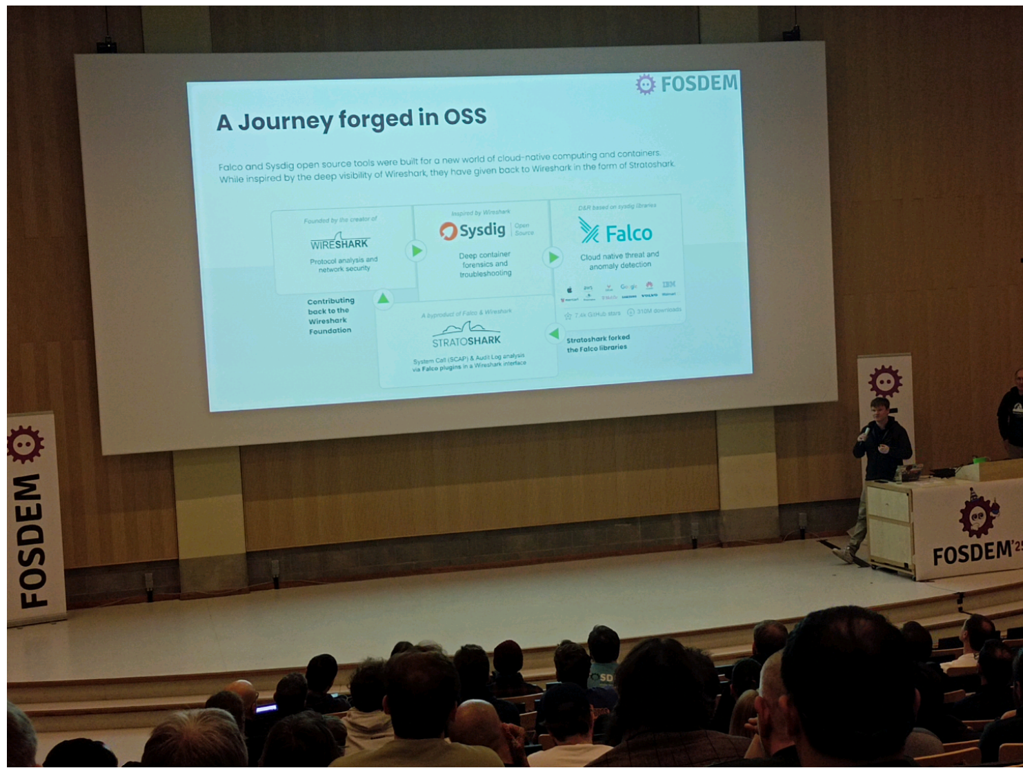

14h00 La fontaine Stratoshark

Define rules on how detect security threaths

Wireshark :protocol and network

Sysdig: container

Falco : librairies

## [FOSDEM 2025 - How browsers REALLY load Web pages](https://fosdem.org/2025/schedule/event/fosdem-2025-4852-how-browsers-really-load-web-pages/)

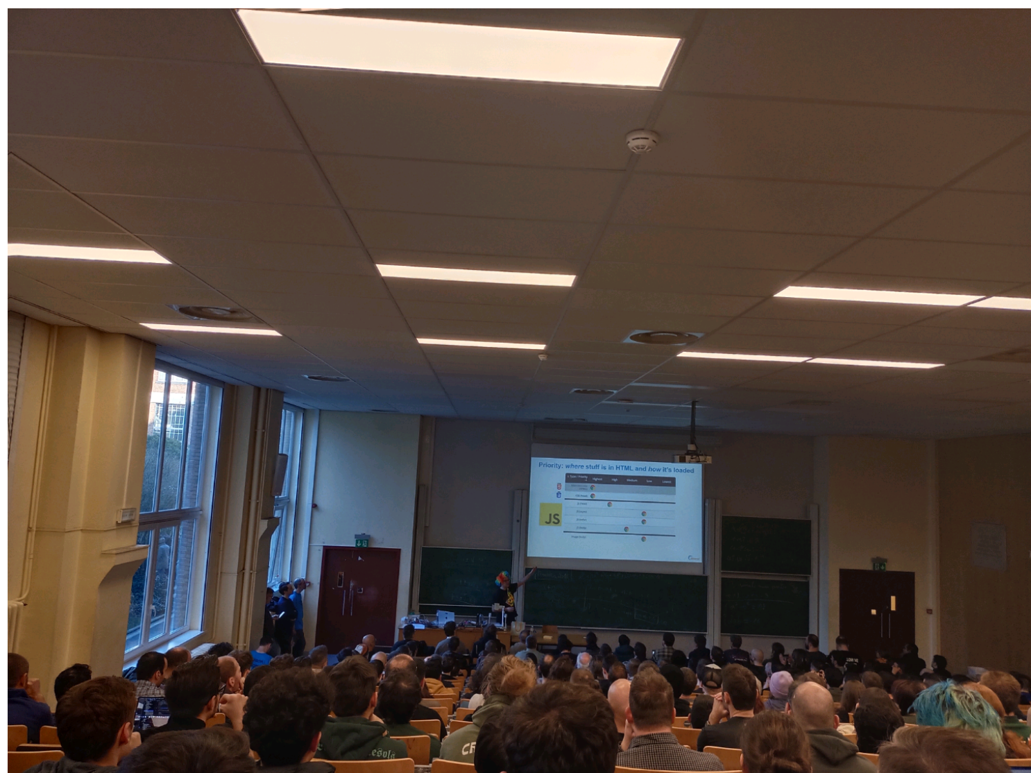

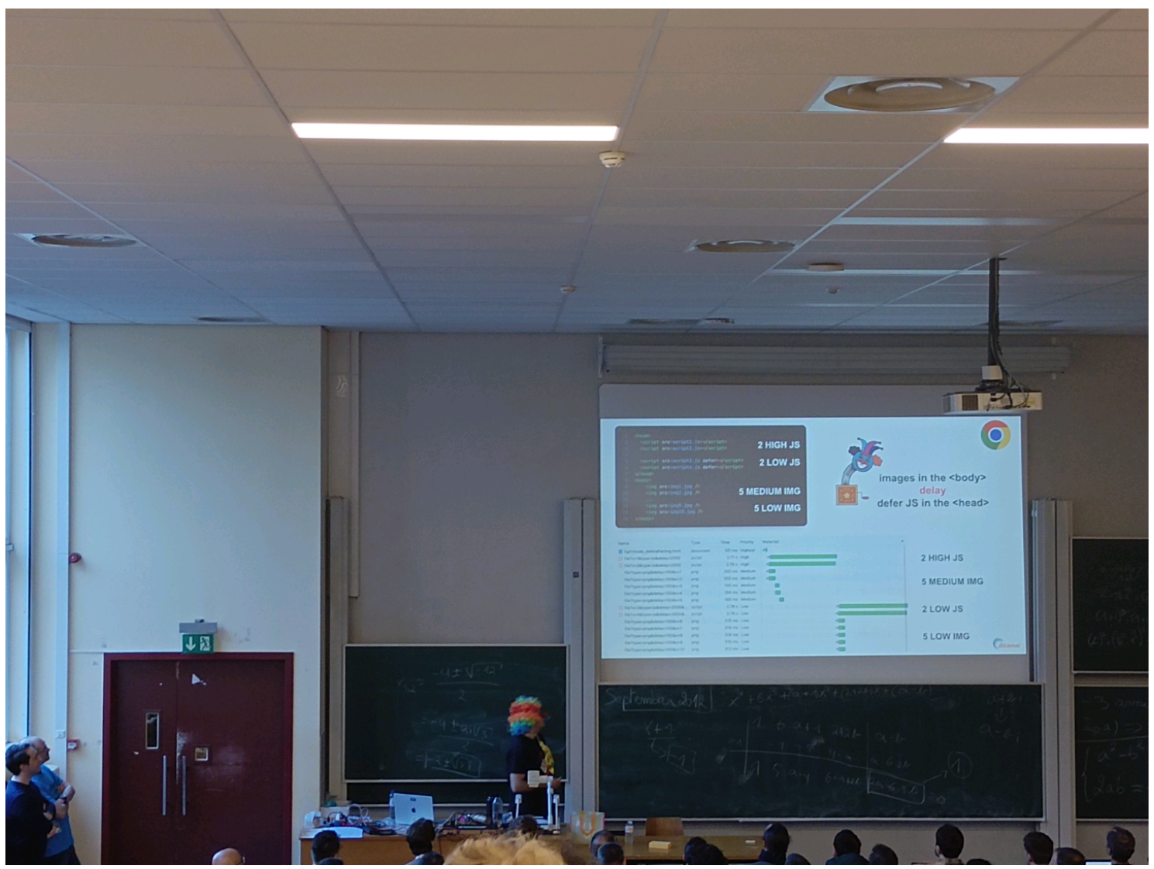

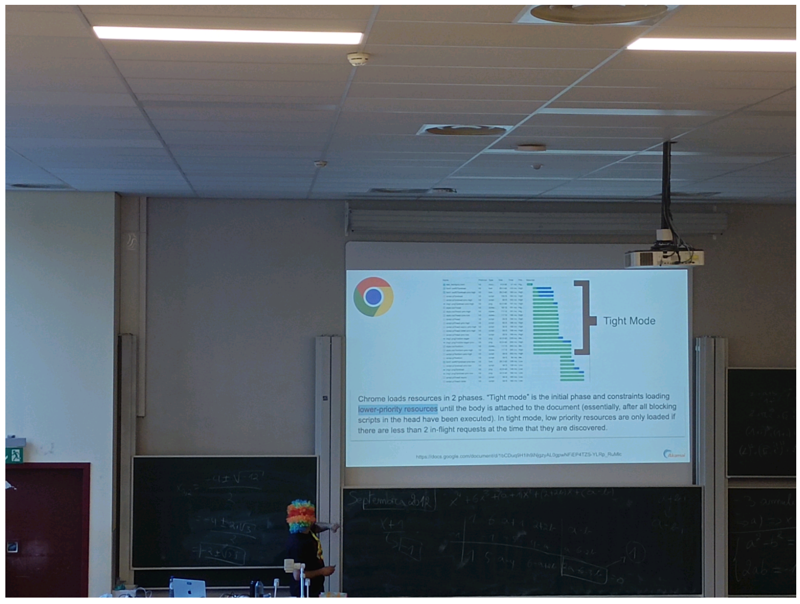

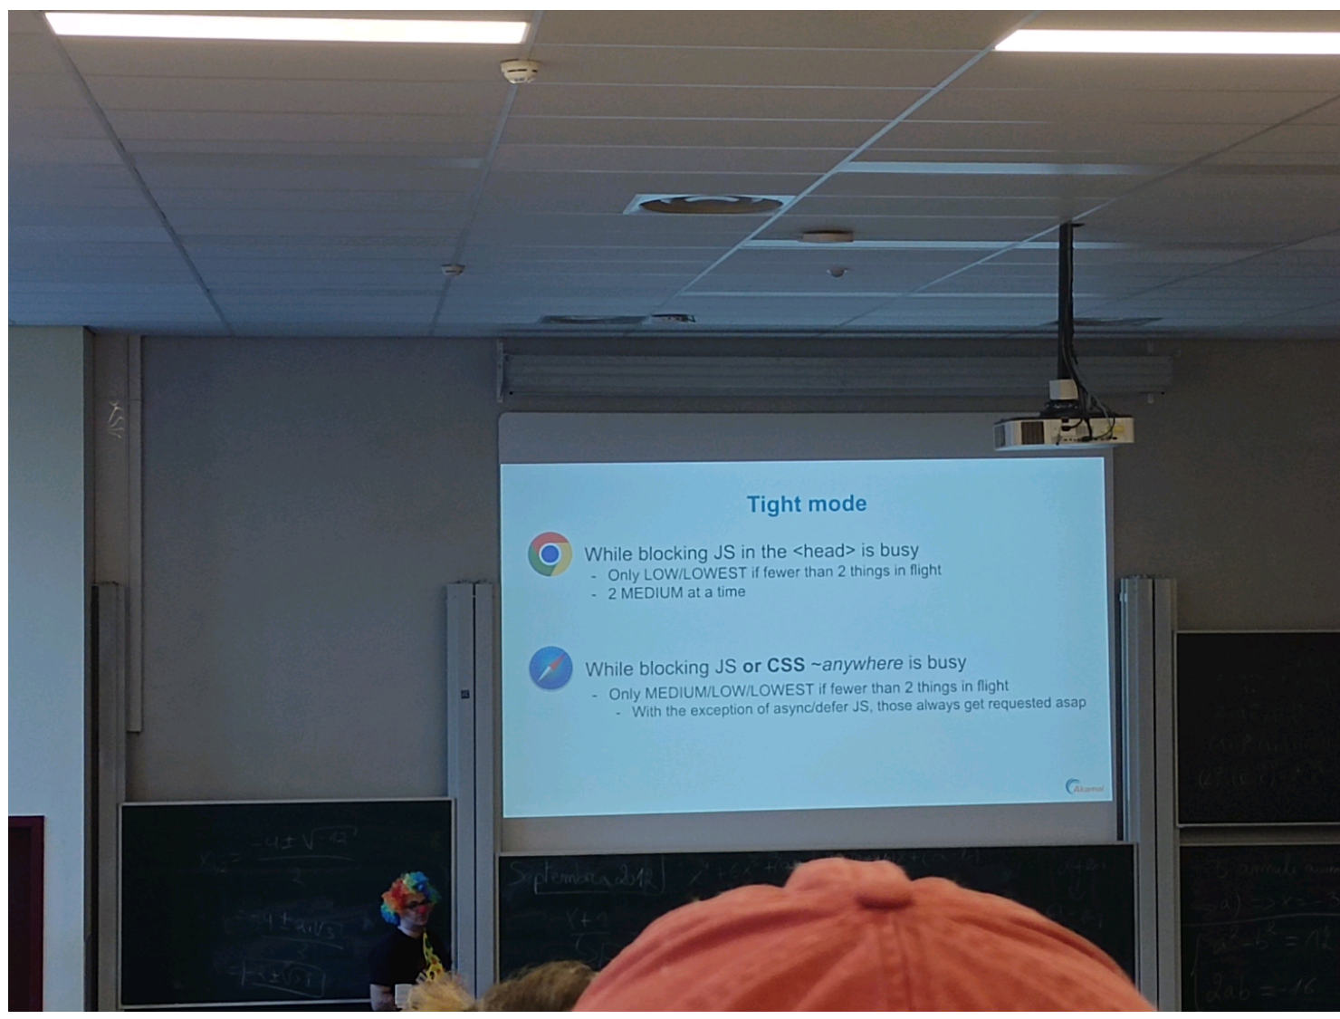

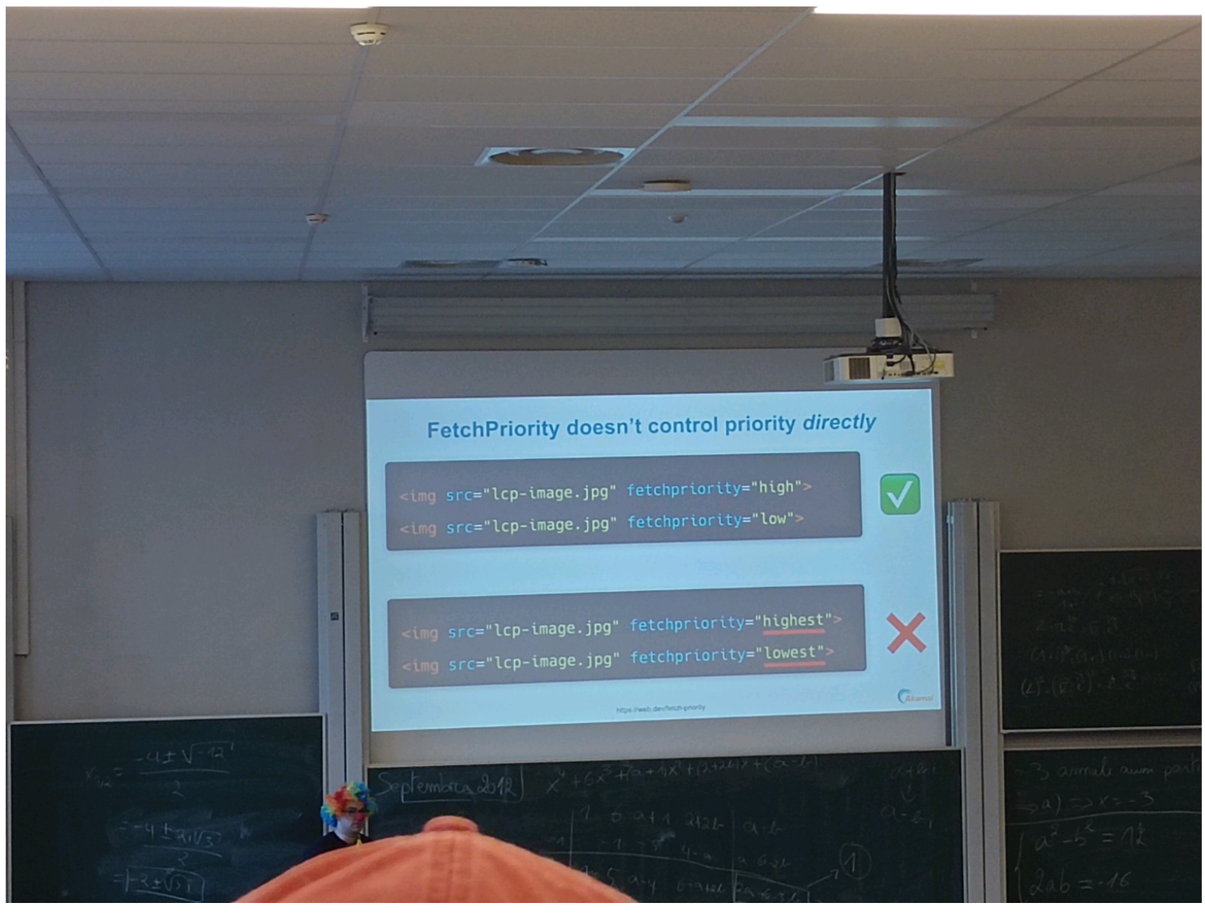

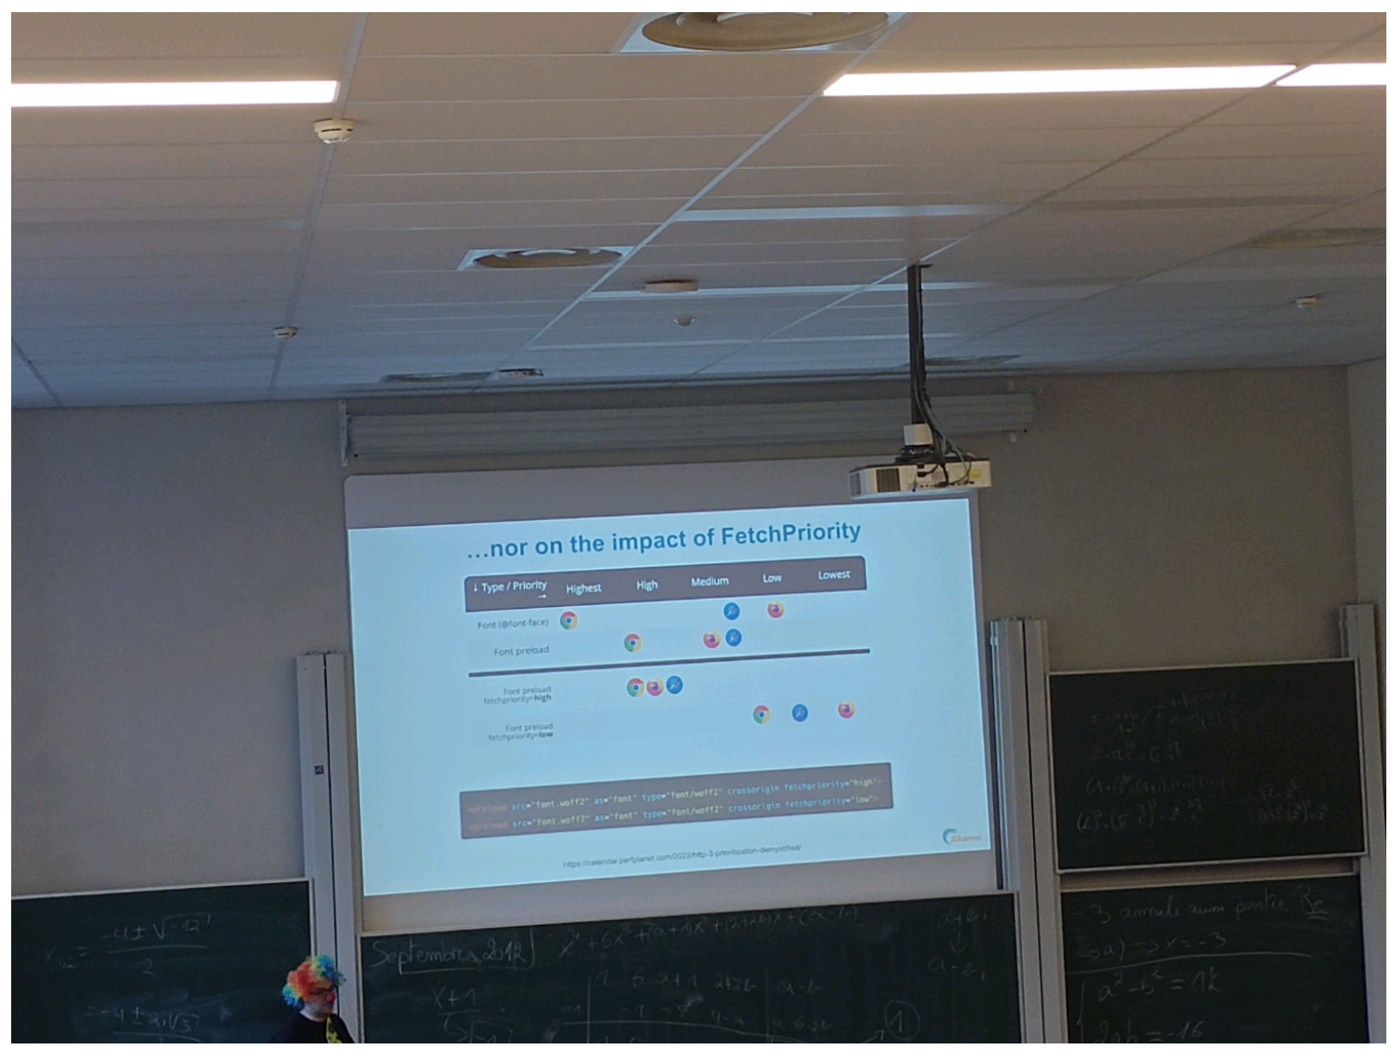

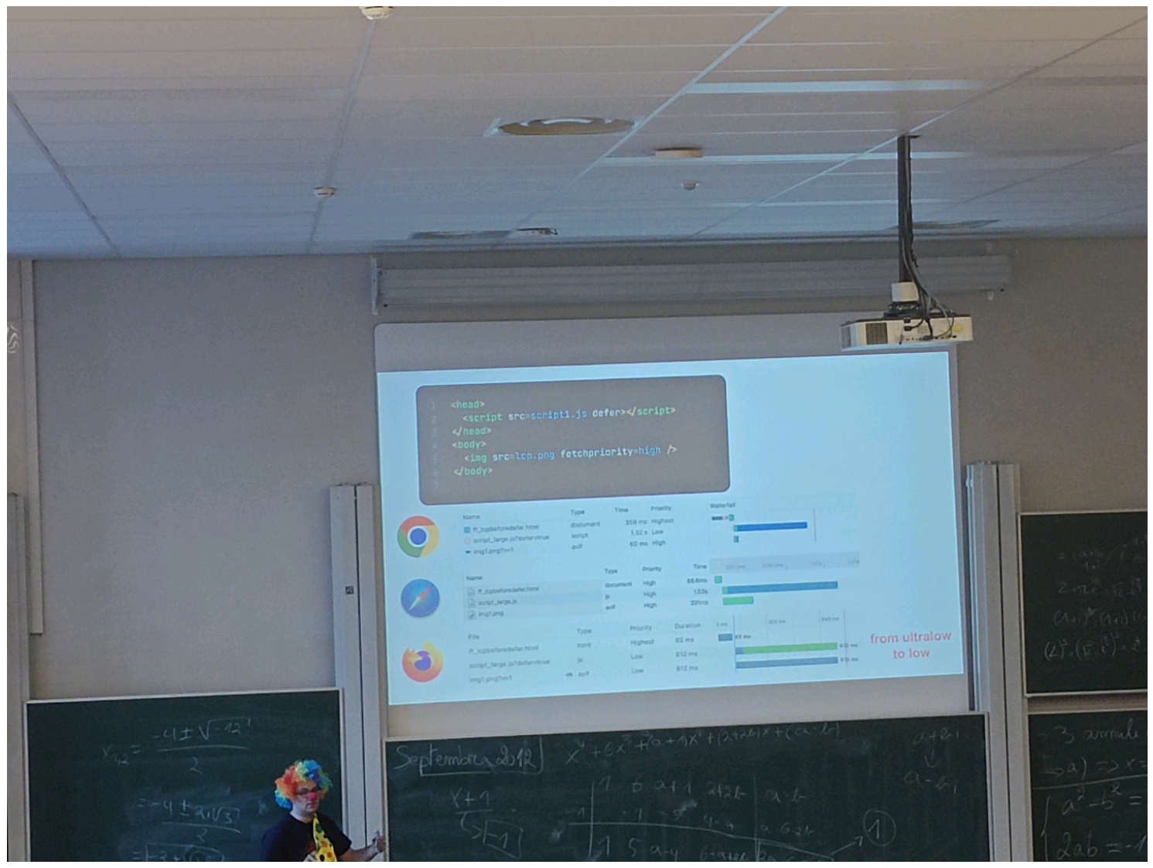

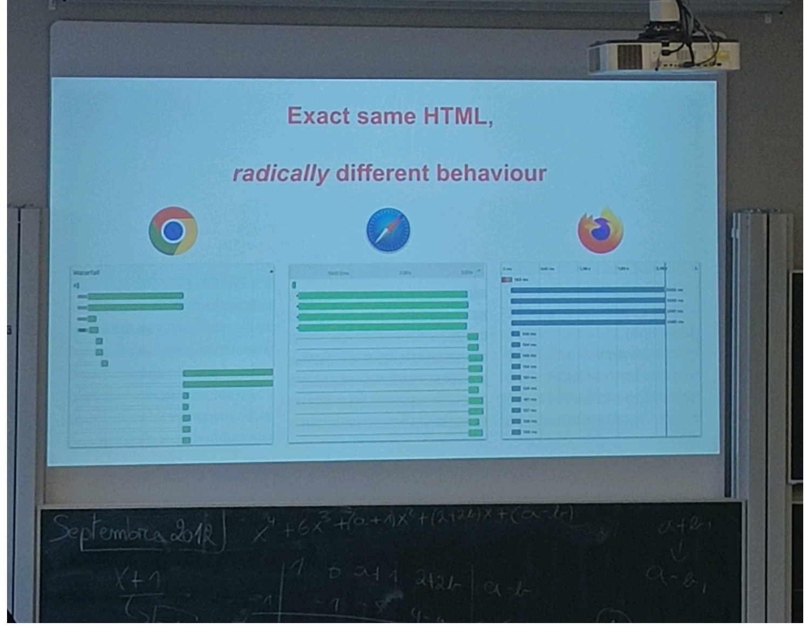

15h10 UA2.220 how web page are loaded

Généralement les navigateurs chargent les données en 2 batch "two step waterfall"

Retour des réponses parfois en inversé, le serveur renvoie en premier la dernière demande

Priorité donnée par la hiérarchie du code ? Priorité mis en place,

Si on envoie 1 demande majeure et toute de suite une mineure puis une autre ..., le canal est surchargé (comme une entrée sortie de rame) et augmentation du risque d'envoyer n'importe quoi n'importe quand

Ce qui amène à différents comportements des navigateurs (différents 2step waterfall)

Exemple : chrome (tight mode/actively delayed) prioritise le html et retarde le JS async ou defer (explicitement demandé en différé) (photo)

La priorité n'est pas donnée par la hiérarchie mais par le type (IMG,JS,etc)

Dans chrome le script est bloqué s'il est dans le head mais pas si il est dans le corps (tout est envoyé en même temps)

Safari ne bloque pas (tight mode) sur le script (mais le fait bien sur les images)

Mozilla n'a pas de tight mode tout est traité immédiatement (trusts the code, importance des best practices)

Comment améliorer / gérer ?

=> FetchPriority

=> Lower or higher (not fixed)

FetchPriority ne marche pas sur safari, ok sur chrome (combiné avec tight mode), très utile sur Firefox (fine grain)

Pbs comment faire fonctionner pour plusieurs navigateurs en même temps ? Les règles ou les interprétations sont parfois complètement contradictoires entre navigateurs

## [FOSDEM 2025 - [RESCHEDULED] CERN CTA Service: writing LHC data to tape with opensource software on commodity hardware](https://fosdem.org/2025/schedule/event/fosdem-2025-5737--rescheduled-cern-cta-service-writing-lhc-data-to-tape-with-opensource-software-on-commodity-hardware/)

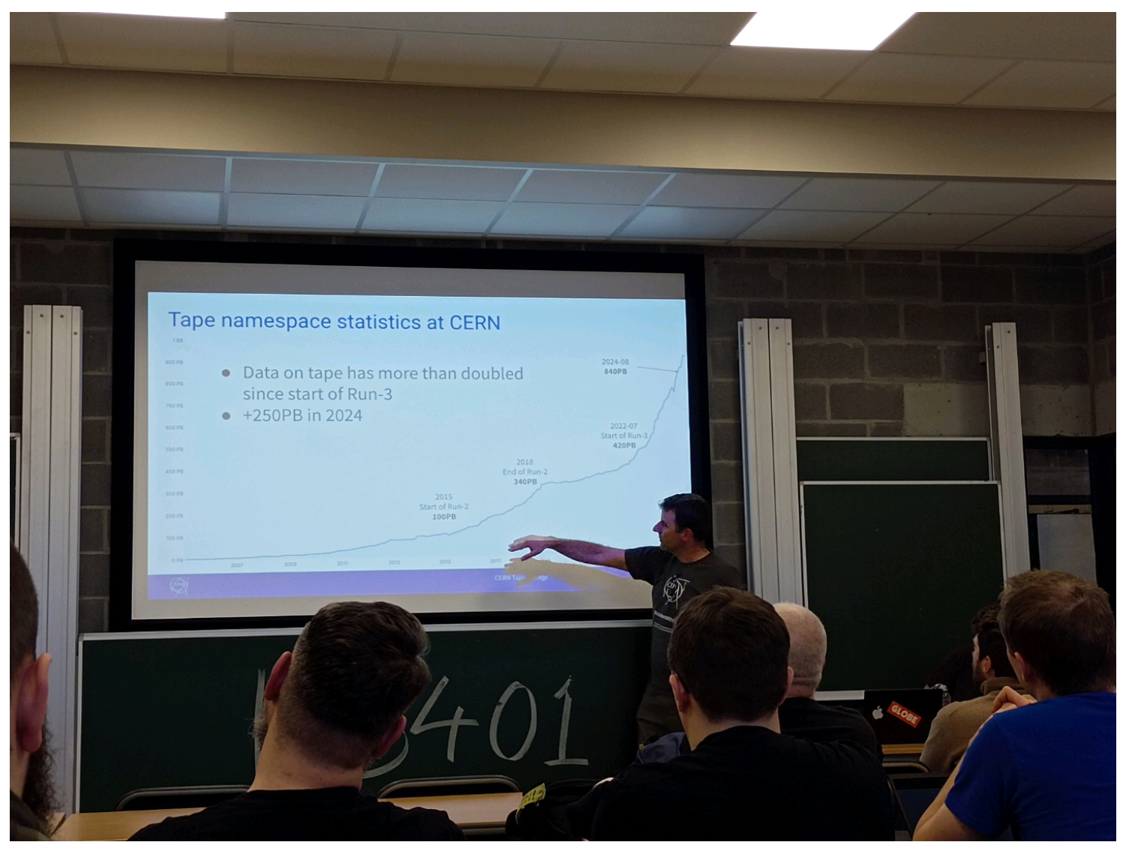

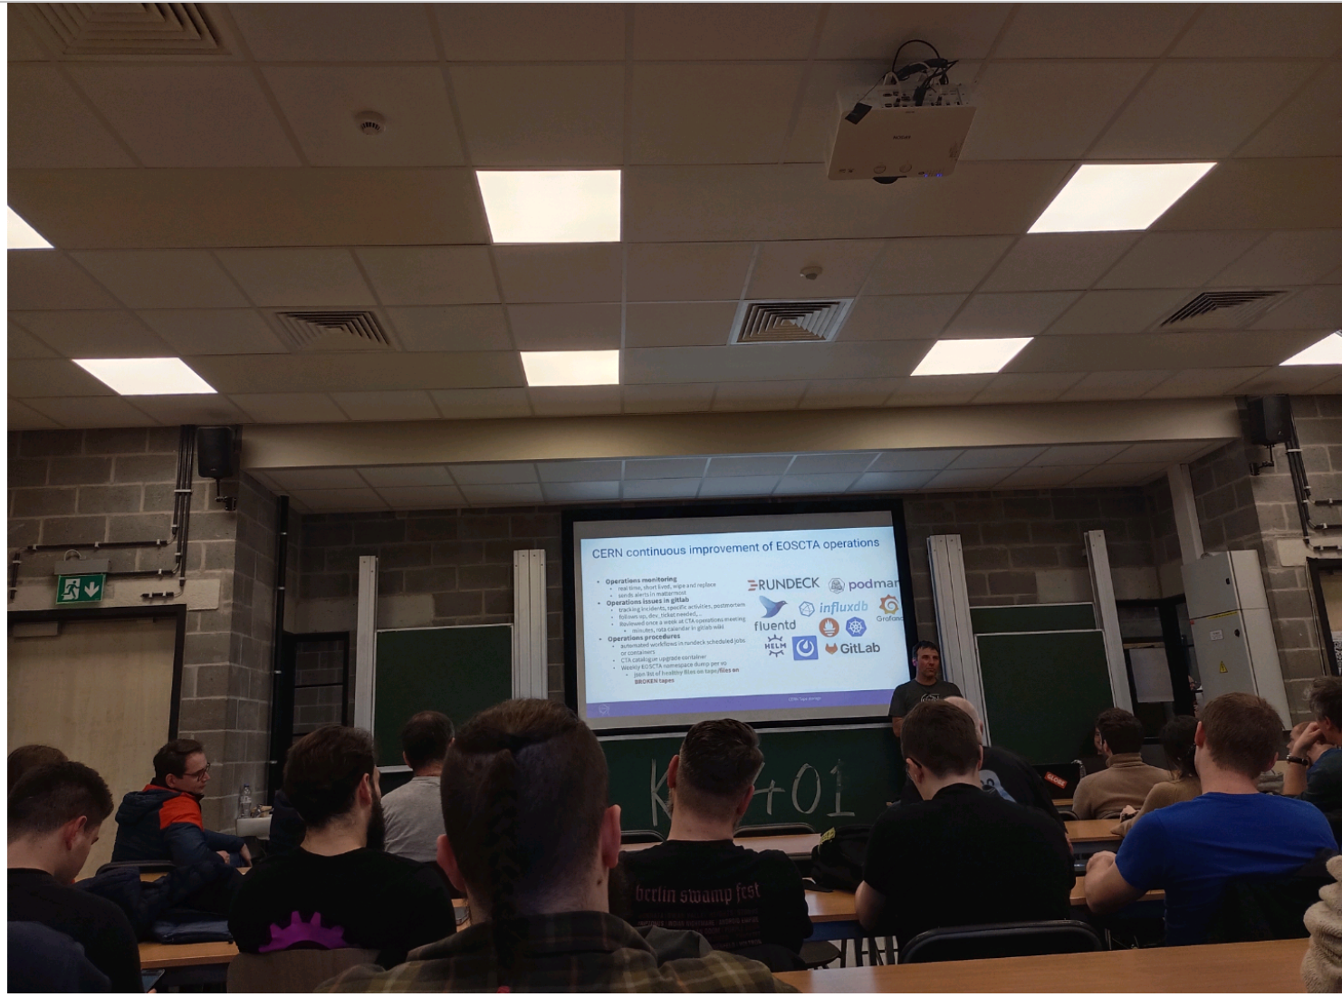

15:55 Software define storage Cern to tape

Exponential data amount (840PB / 2015 100PB) expected 1.3EB around 2025

Store in both private and open techno

Castor => EOS+FTS+tape

CTA

Balance entre l'archivage et la lecture, flexible sur la répartition mais toujours garde de la dispo pour l'archivage d'un côté et la lecture de l'autre

## [FOSDEM 2025 - What if Log4Shell were to happen today?](https://fosdem.org/2025/schedule/event/fosdem-2025-6281-what-if-log4shell-were-to-happen-today-/)

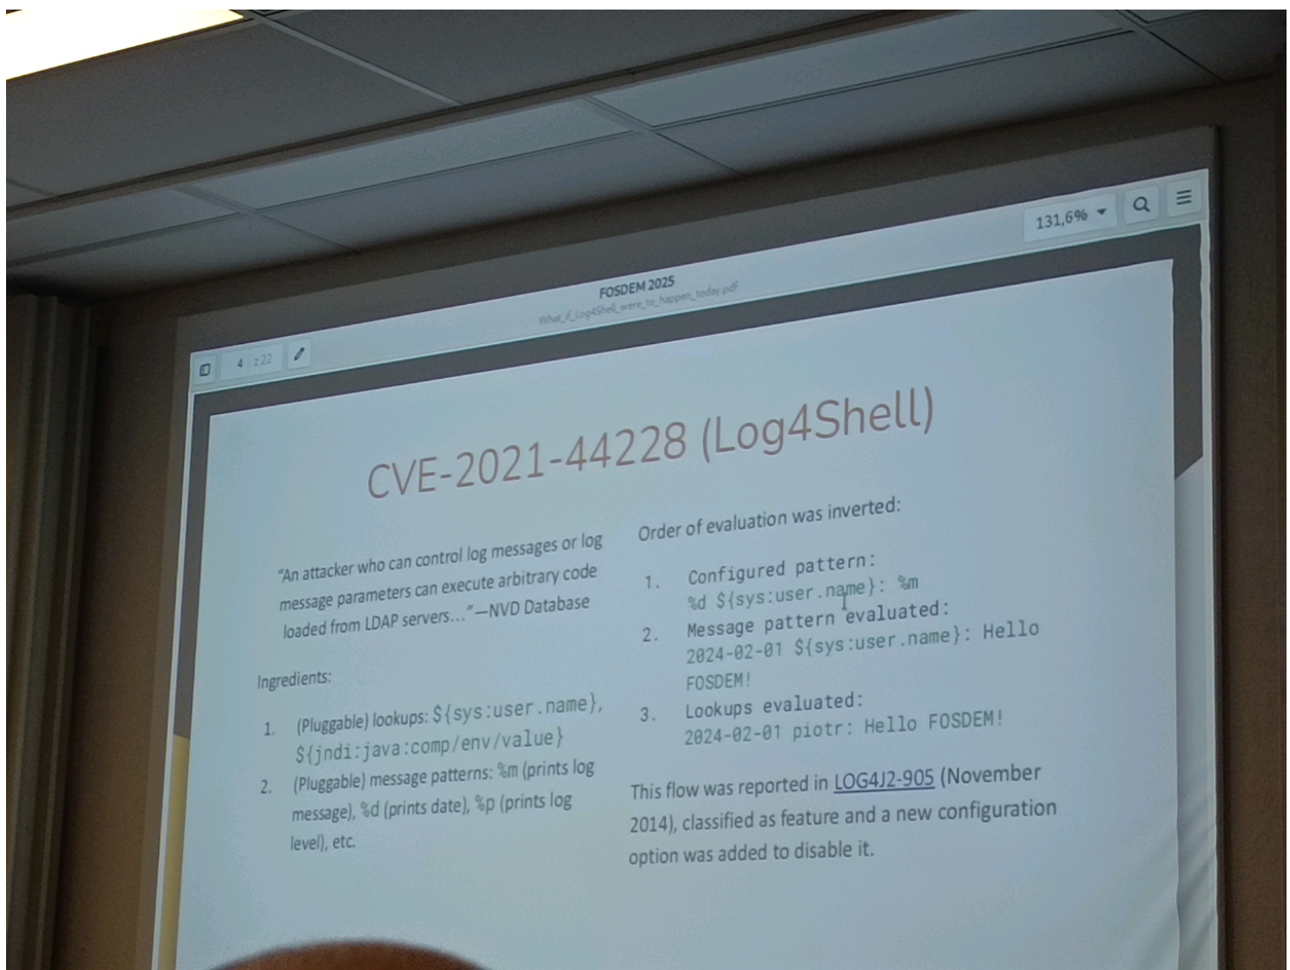

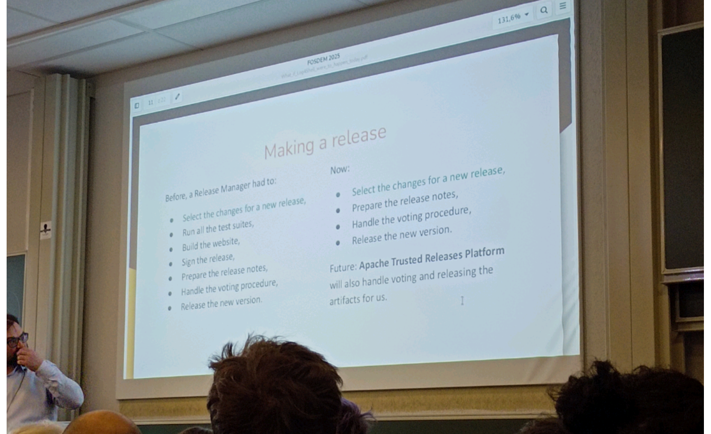

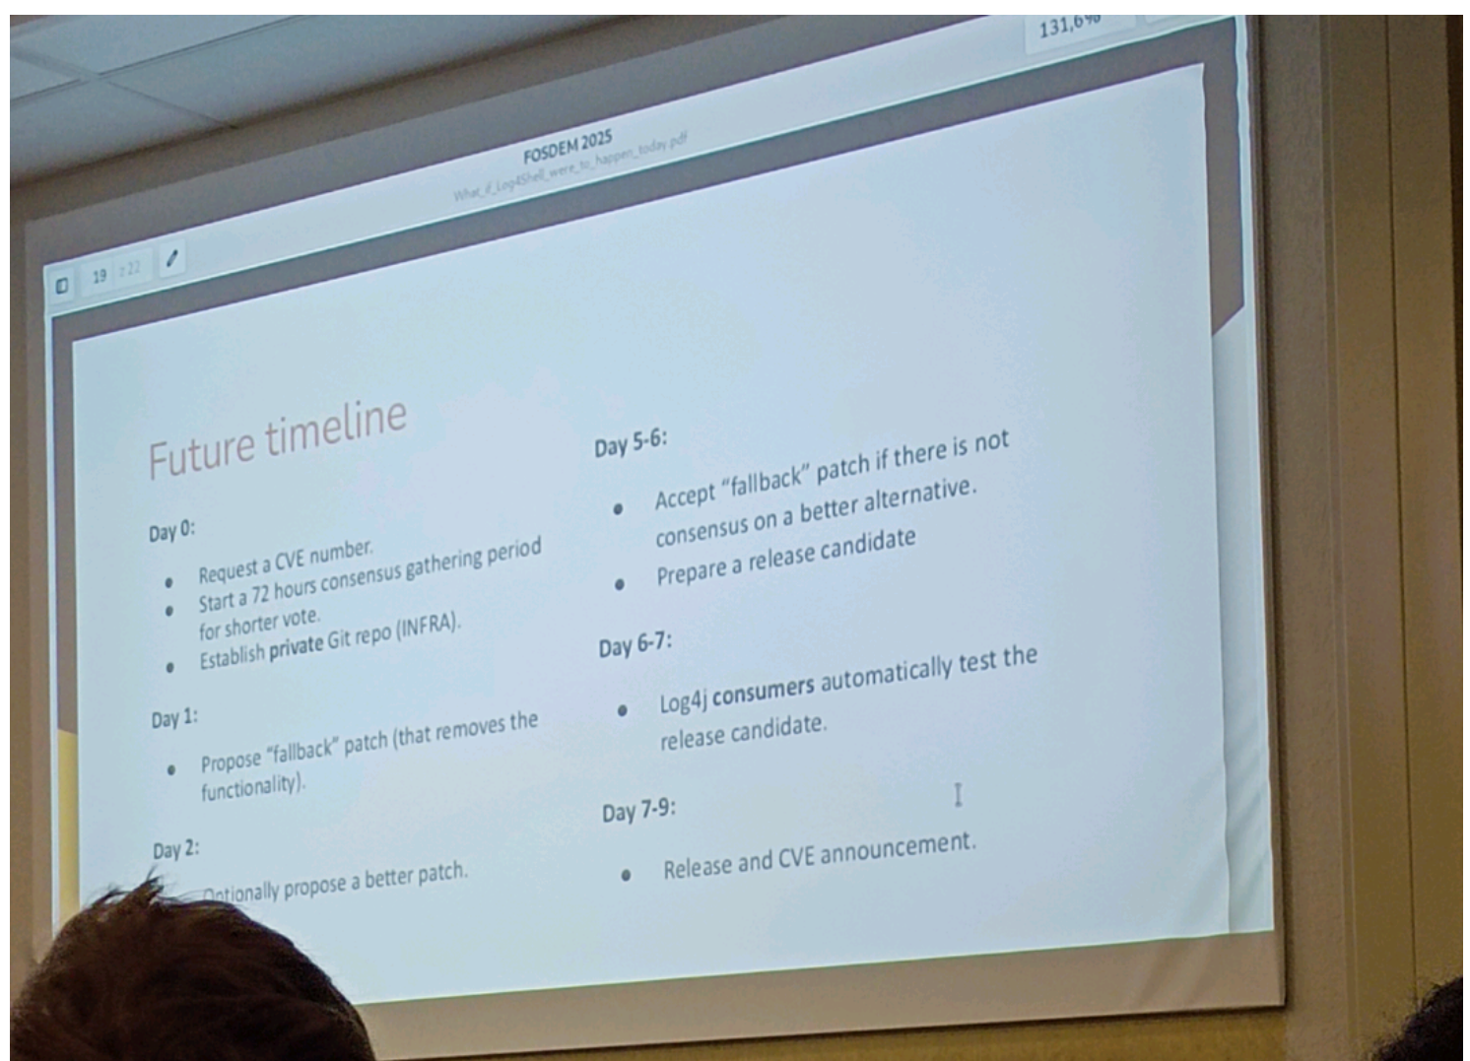

17h00 UB4.132 what if log4shell

Cve 2021 44228 remote execution code

Reason: inverted order of evaluation (known and fixed on optional feature in 2014-5 and then forgotten?)

How improve ?

* Reproducibility
* Constant upgrade if tests ok
* Ensure CI/CD
* Ensure tests

testing: the pb lot of tests with failures, long time to process, how to improve? :

* Fuzzing
* Dynamic tests

Handling feature:

SBOM:

Documentation:

## [FOSDEM 2025 - How Threat Actors Are Weaponizing Your Favorite Open-Source Package Registry](https://fosdem.org/2025/schedule/event/fosdem-2025-5662-how-threat-actors-are-weaponizing-your-favorite-open-source-package-registry/)

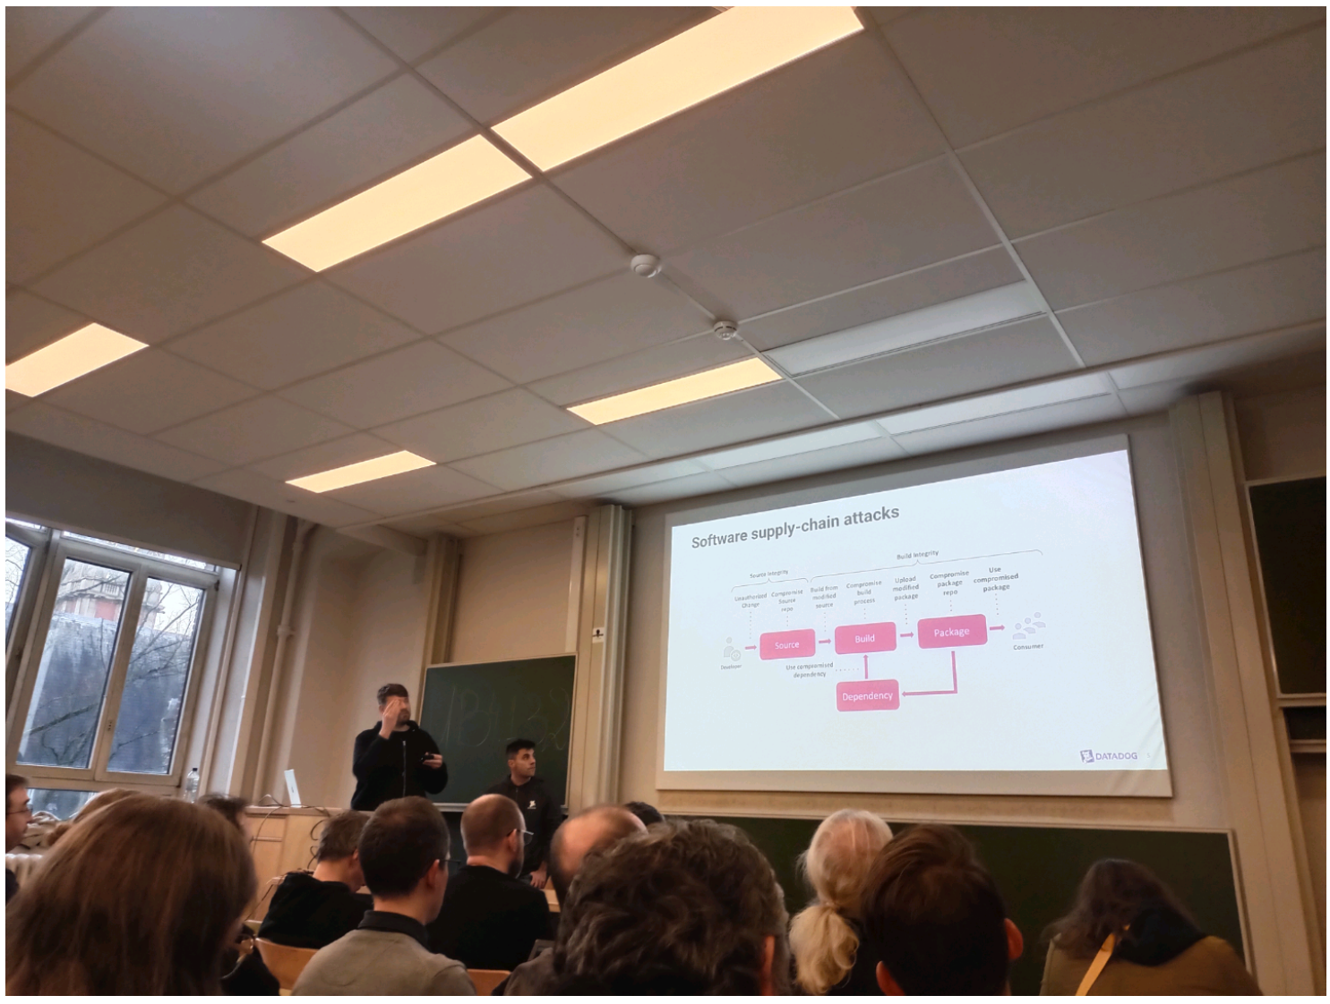

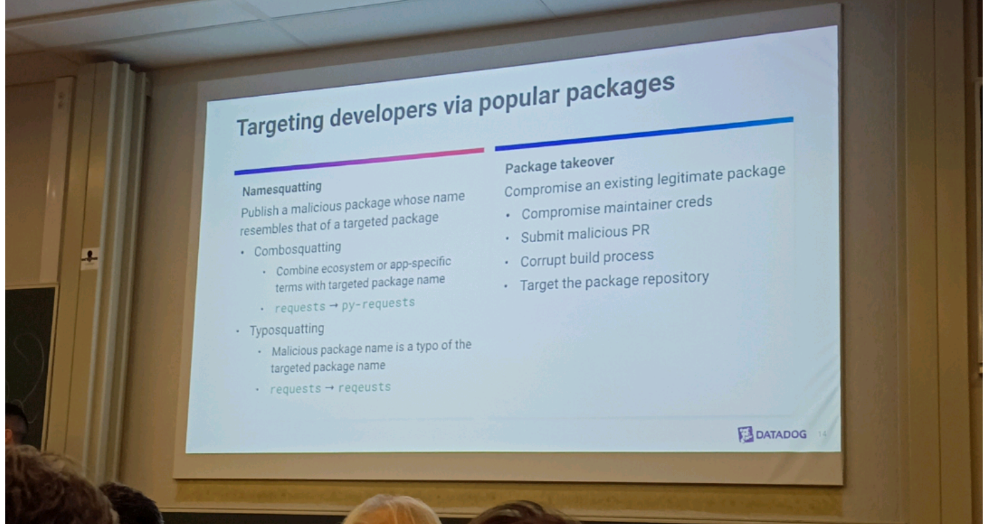

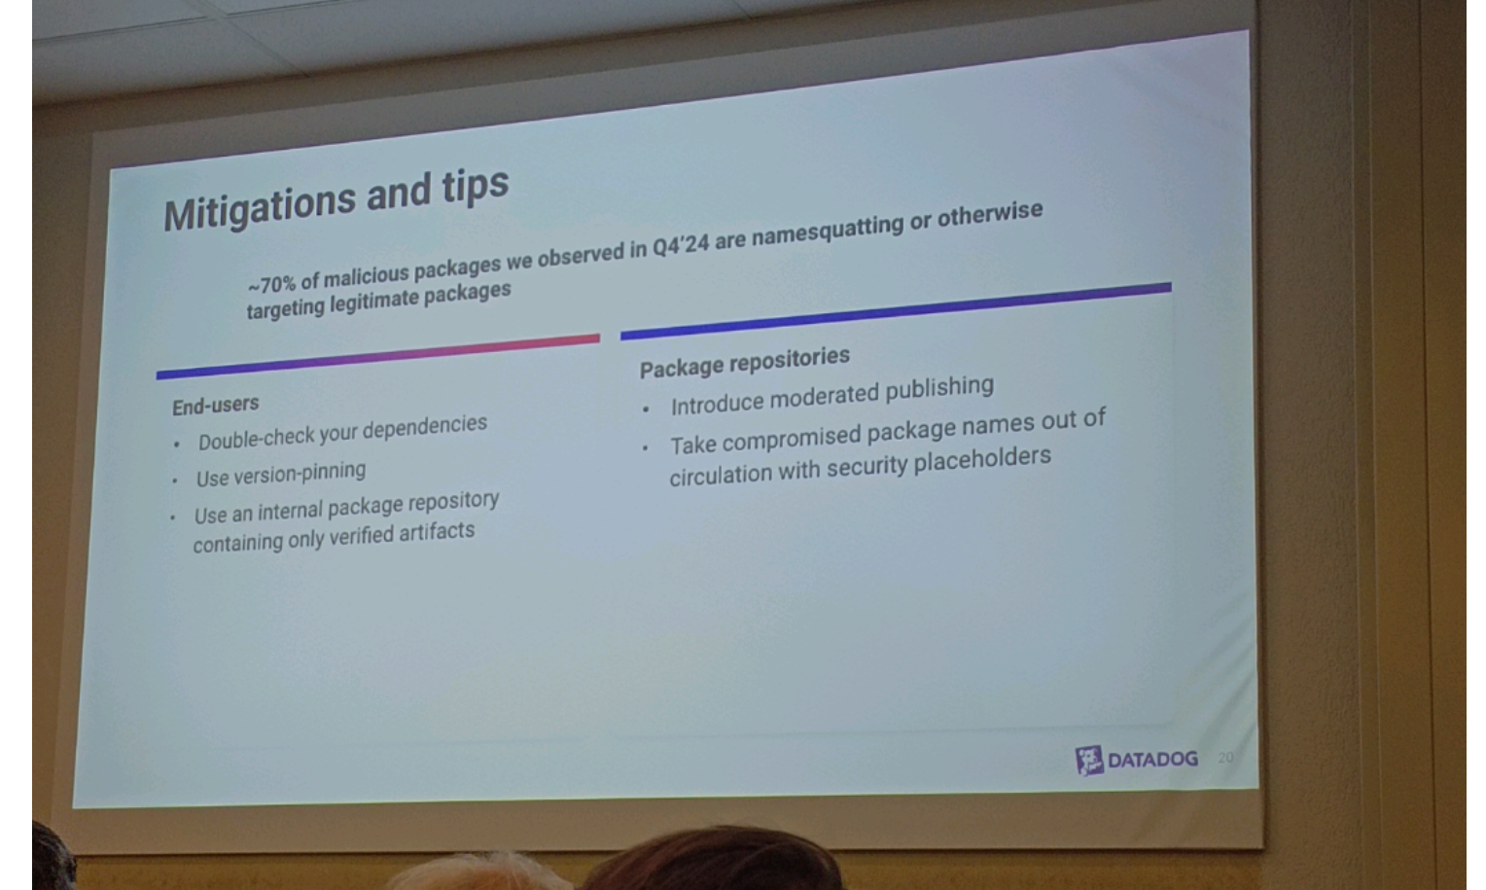

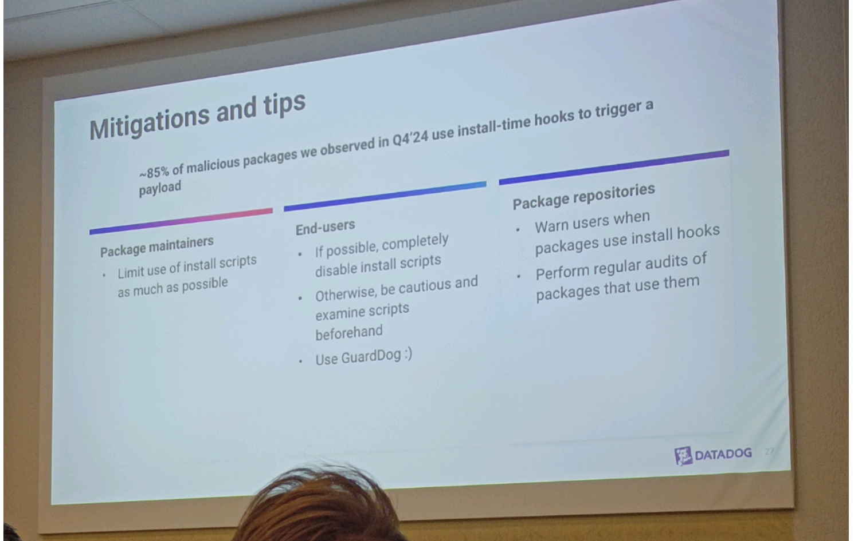

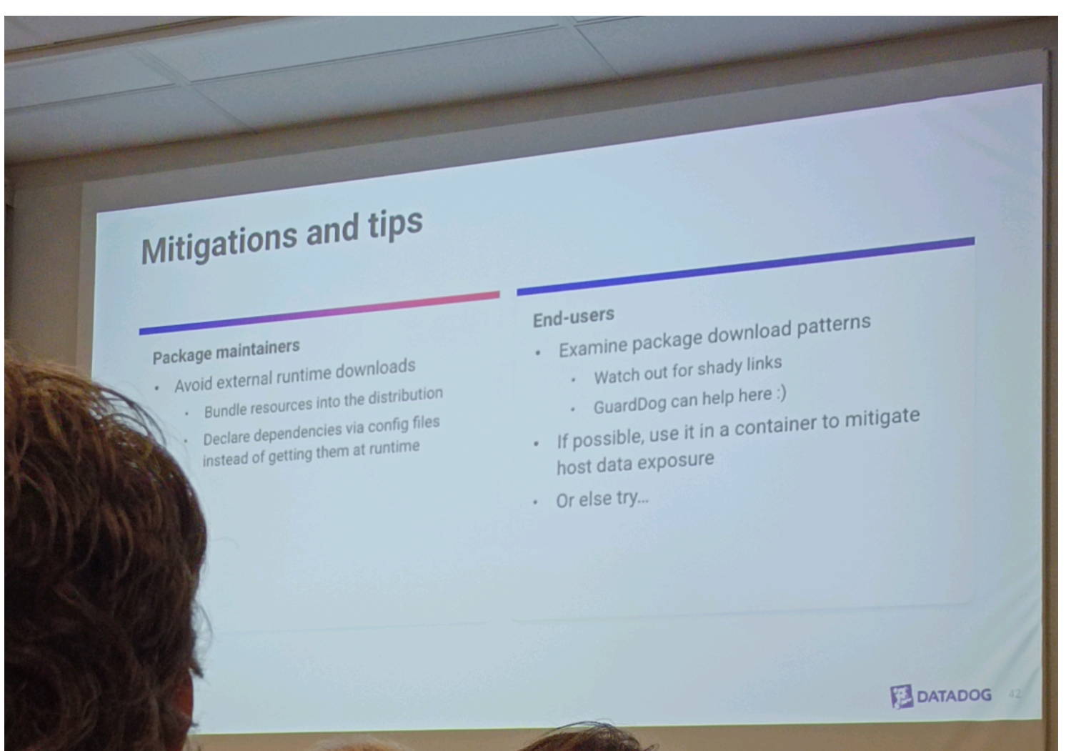

17h30 threat actors weaponize registry (Datadog)

Supply chain attack: eg. Solar winds

Plusieurs points d'attaque possible

Comment protéger

* Guarddog
* Rigueur et awareness
* Ne pas accepter du code illisible /obstrué
* Supply chain firewall

Type d'attaque

* Nommage de paquet qui ressemble
* Incitation a télécharger et exécuter du code malicieux à notre insu
* Planquer le code malicieux dans du code difficilement lisible

<https://github.com/DataDog/guarddog> GuardDog is a CLI tool that allows to identify malicious PyPI and npm packages or Go modules. It runs a set of heuristics on the package source code (through Semgrep rules) and on the package metadata.

<https://github.com/DataDog/supply-chain-firewall> Supply-Chain Firewall is a command-line tool for preventing the installation of malicious PyPI and npm packages. It is intended primarily for use by engineers to protect their development workstations from compromise in a supply-chain attack.

<https://github.com/DataDog/malicious-software-packages-dataset> This repository is an **open-source dataset of 6488 malicious software packages** (and counting) identified by Datadog, as part of our security research efforts in software supply-chain security. Most of the malicious packages have been identified by [GuardDog](https://github.com/DataDog/guarddog).

<https://securitylabs.datadoghq.com/> Datadog Security Labs

# Sunday

## [FOSDEM 2025 - GIMP 3 and beyond](https://fosdem.org/2025/schedule/event/fosdem-2025-6344-gimp-3-and-beyond/)

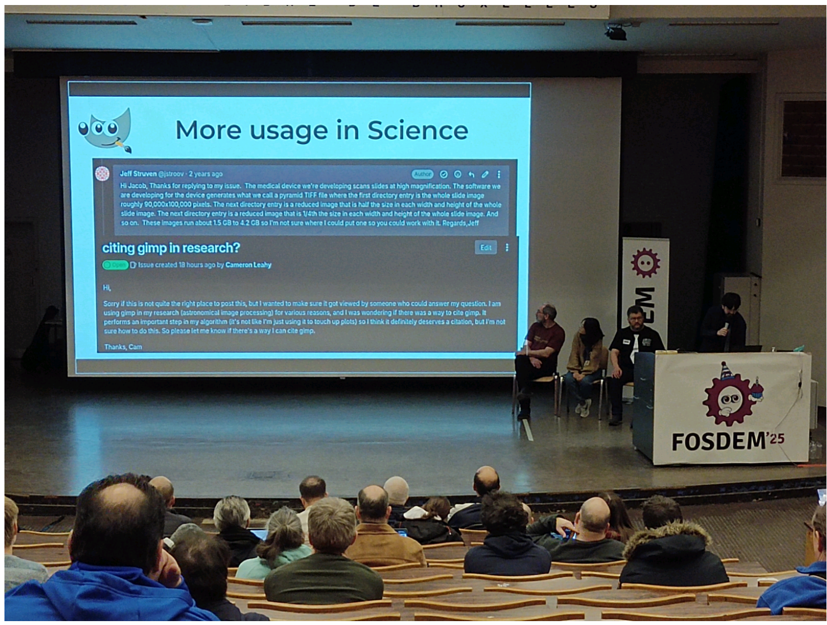

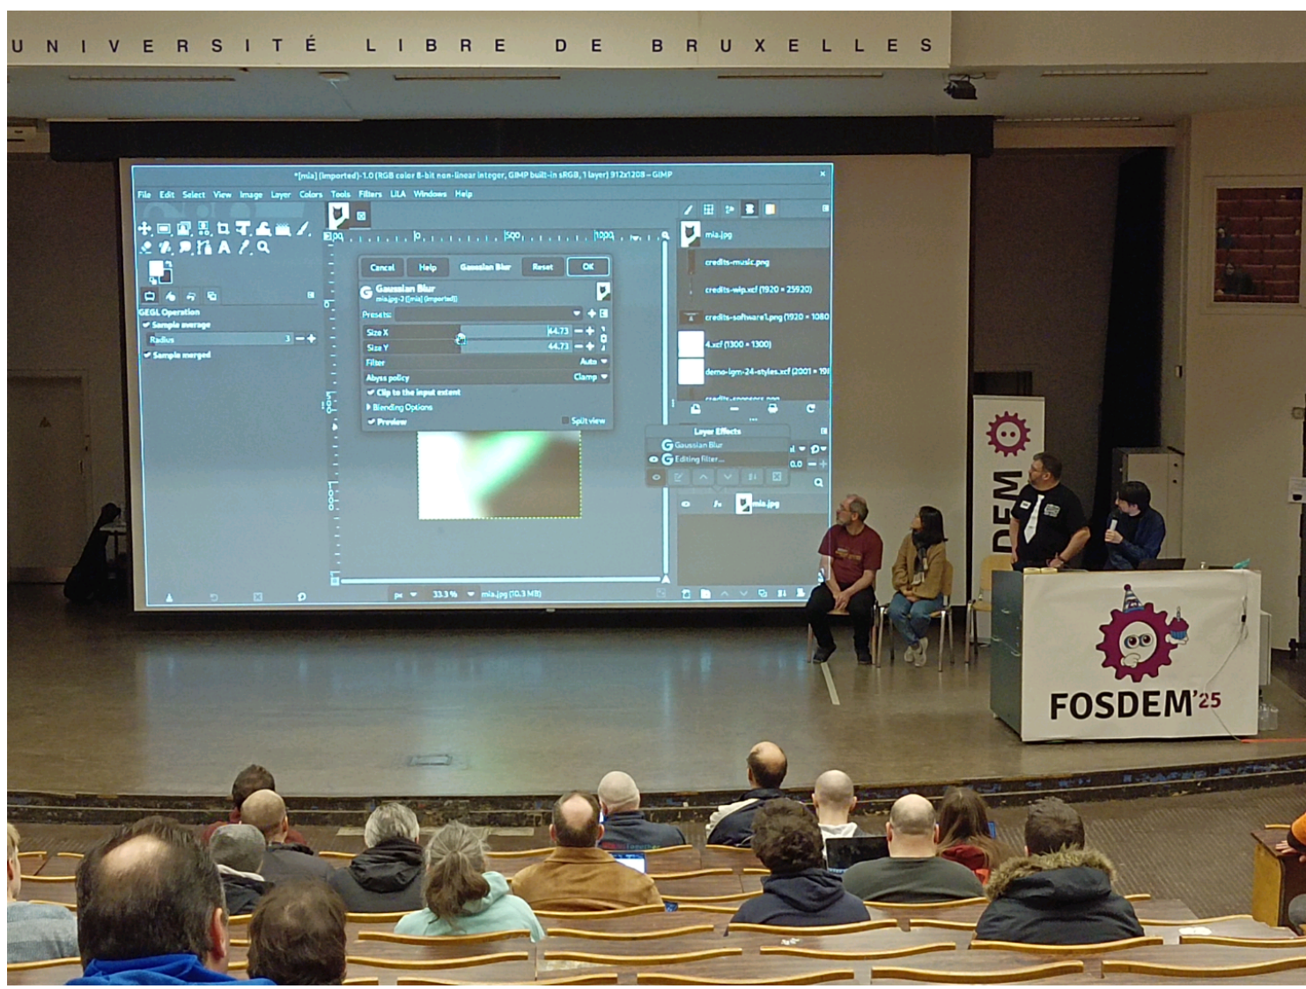

10h00 Janson Gimp 3

Better Support PSD

Tiff

More non destructive editing : from blur to original for example

Plugin API

Ctx (vector, …)

Gimp 3 RCs ongoing, final soon (follow on Gitlab)

## [FOSDEM 2025 - Room changeover & Intro to the Public sector Open Source block](https://fosdem.org/2025/schedule/event/fosdem-2025-6692-room-changeover-intro-to-the-public-sector-open-source-block/)

11h EU AW1.120 presentation & open discussion

## [FOSDEM 2025 - Making Workspaces Work Together (And Across Borders)](https://fosdem.org/2025/schedule/event/fosdem-2025-6406-making-workspaces-work-together-and-across-borders-/)

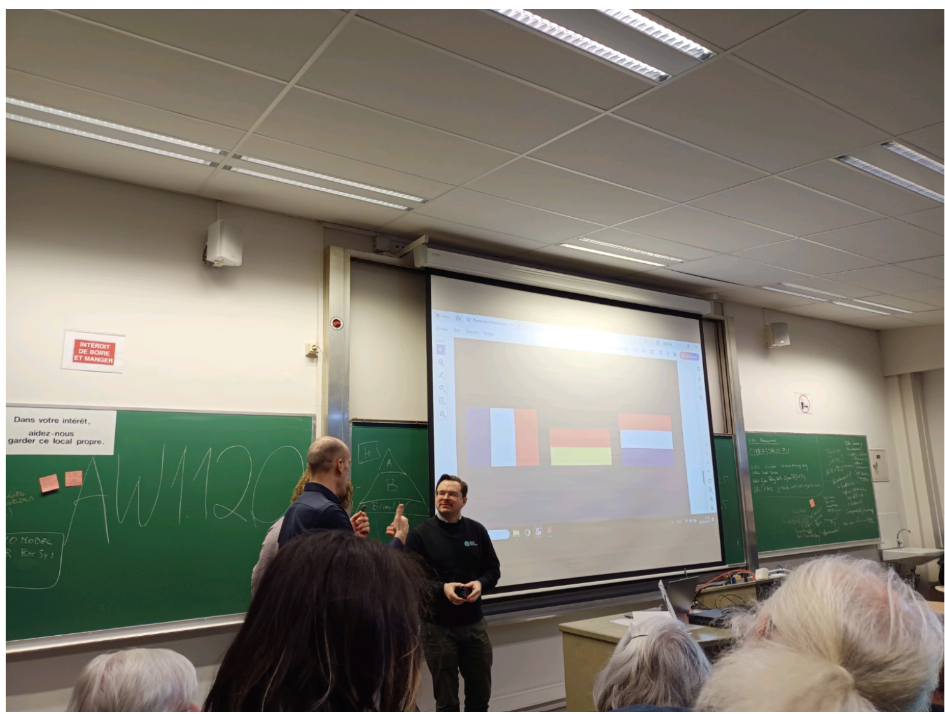

11h20 working together across borders

(FR DE gov)

OpenDesk (DE)

'lasuite' (FR)

Accelerating the process on sharing and working together

Added (NED) to the challenges

<https://lasuite.numerique.gouv.fr/>

<https://www.opendesk.eu/en>

## [FOSDEM 2025 - openDesk and beyond: building the EuroStack](https://fosdem.org/2025/schedule/event/fosdem-2025-5729-opendesk-and-beyond-building-the-eurostack/)

11h35 Eurostack

Nécessité d'indépendance sur les technologies pour l'Europe, mise sur OSS provenant d'Europe

Actuellement on essait de définir qu'est ce que l'eurostack qu'on veut mettre en place, identifier les composants

Q Existe il un retour sur l'expérience de ces challenges A avec l'arrivée de NED le process de retour d'expérience pourrait se construire

Q how garanti it's not going to die A both OSS and partners to keep on going , through cooperation, more implications nor only garanti on tools/products but also people

Q projet planifié initialement de 2020~ à 2027, mais après ? A wider scope, create opportunities?

Q how promote in the EU (like opendesk or laduite) ? A first presentation leverage, prove by example that it will help a better co-working between gov, educate the colleagues in the parlement

Q how can we involve private sectors ? A now how govs work and their needs, because they want to work from now, start with OSS because is accessible and usable already ,

Q OSS make private techno evolve so fast A agreement

Communication issue, education issue , need to improve

## [FOSDEM 2025 - Digital Identies in disarray](https://fosdem.org/2025/schedule/event/fosdem-2025-6510-digital-identies-in-disarray/)

12h Digit identites

eID (European identy)

Why ? Because now we use ID like Google, apple and so, not European ID, we don't know where the data go

## [FOSDEM 2025 - Accelerating Digital Transformation in Europe: The Role of Digital Public Goods and Open Source Collaboration](https://fosdem.org/2025/schedule/event/fosdem-2025-5850-accelerating-digital-transformation-in-europe-the-role-of-digital-public-goods-and-open-source-collaboration/)

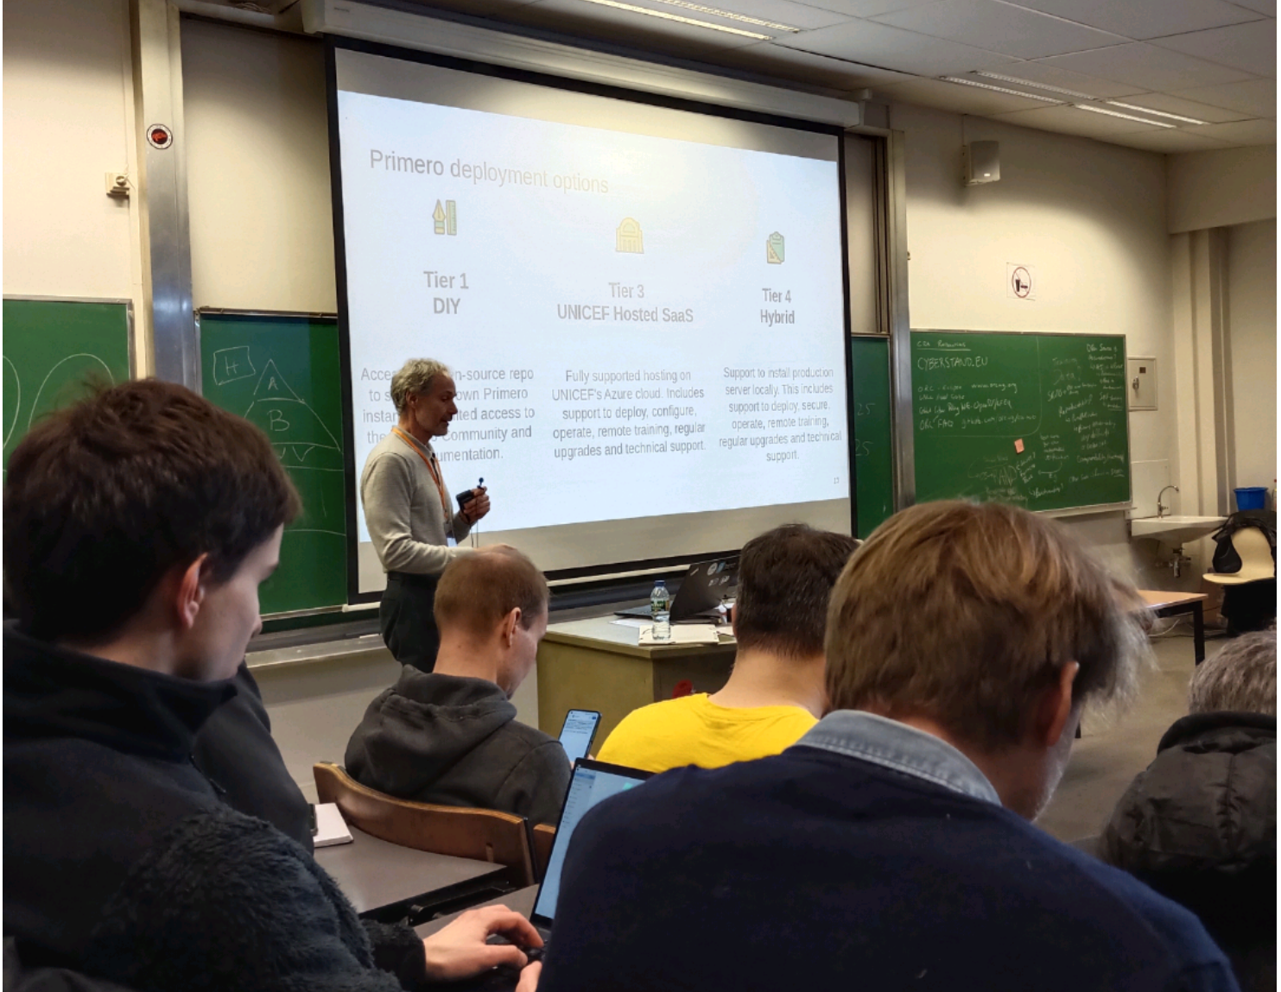

12h15 digit commons Eu digit transformation

Digit public good: commodity for ppl provided by gov for no cost to the users

DPG standards (voir présentation)

Primero: a digital public good developed for children protection (unicef, …) instead of duplicate for each org, an OS tool to handle a common issue/need,

## [FOSDEM 2025 - Government Collaboration - Intro](https://fosdem.org/2025/schedule/event/fosdem-2025-6707-government-collaboration-intro/)

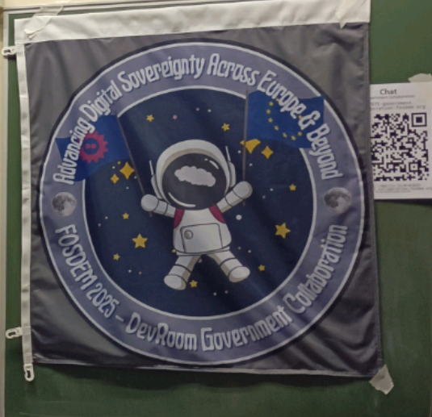

13h10 AW1.126 gov collab - digit sovereignty across Eu and world

## [FOSDEM 2025 - How is Development and Collaboration Done in Public Sector Open Source Software Projects? Insights from Six Mature Case Studies](https://fosdem.org/2025/schedule/event/fosdem-2025-5379-how-is-development-and-collaboration-done-in-public-sector-open-source-software-projects-insights-from-six-mature-case-studies/)

13h15 6 cases study

* Energyplus
* Os2form
* Oskari
* Geotrek
* Dinum
* Io-app

Core team: 15~ ppl team

GitHub

Formal & agile process

Centered around 1 entity

Decisions top-down

Vendors / suppliers: local / national

Users scope : first limited for then much wider

Improve: public involvement, growing , transparency

## [FOSDEM 2025 - OSOR Handbook on Open Source Software in Public Administration](https://fosdem.org/2025/schedule/event/fosdem-2025-5693-osor-handbook-on-open-source-software-in-public-administration/)

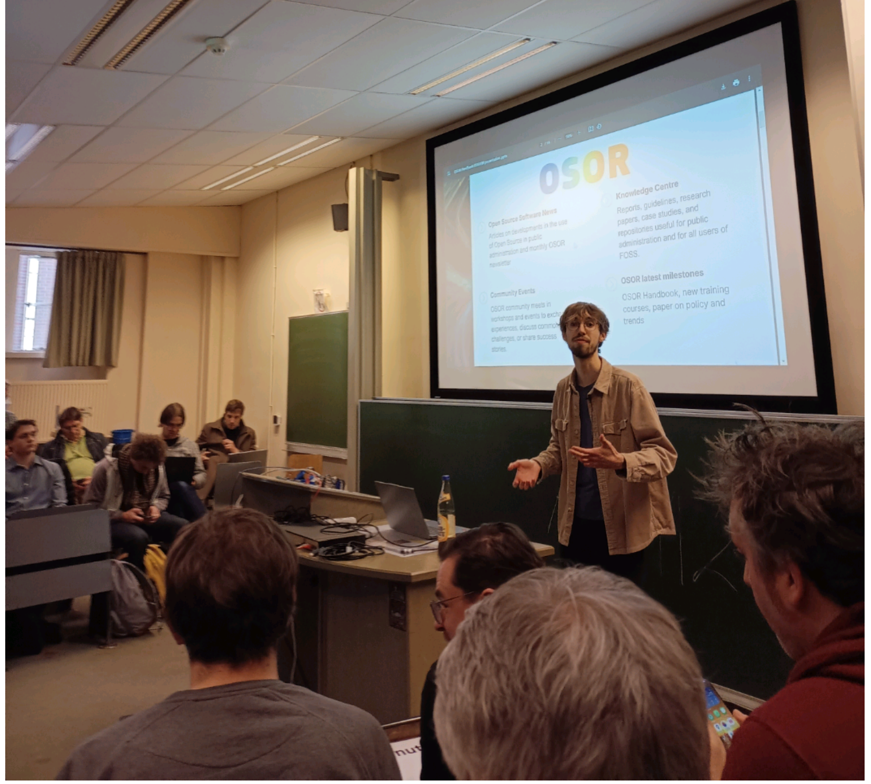

13h30 Osor handbook

OSOR: OS observatory for Eu

Handbook: guide to Eu public sector

From 2022

Feedback and open workshop in 2024

Sharing into public sector

How / Rex

* Consultation
* Simplify (from technique knowledge and policies knowledge)
* Community

## [FOSDEM 2025 - Nubo: the French government sovereign cloud](https://fosdem.org/2025/schedule/event/fosdem-2025-6234-nubo-the-french-government-sovereign-cloud/)

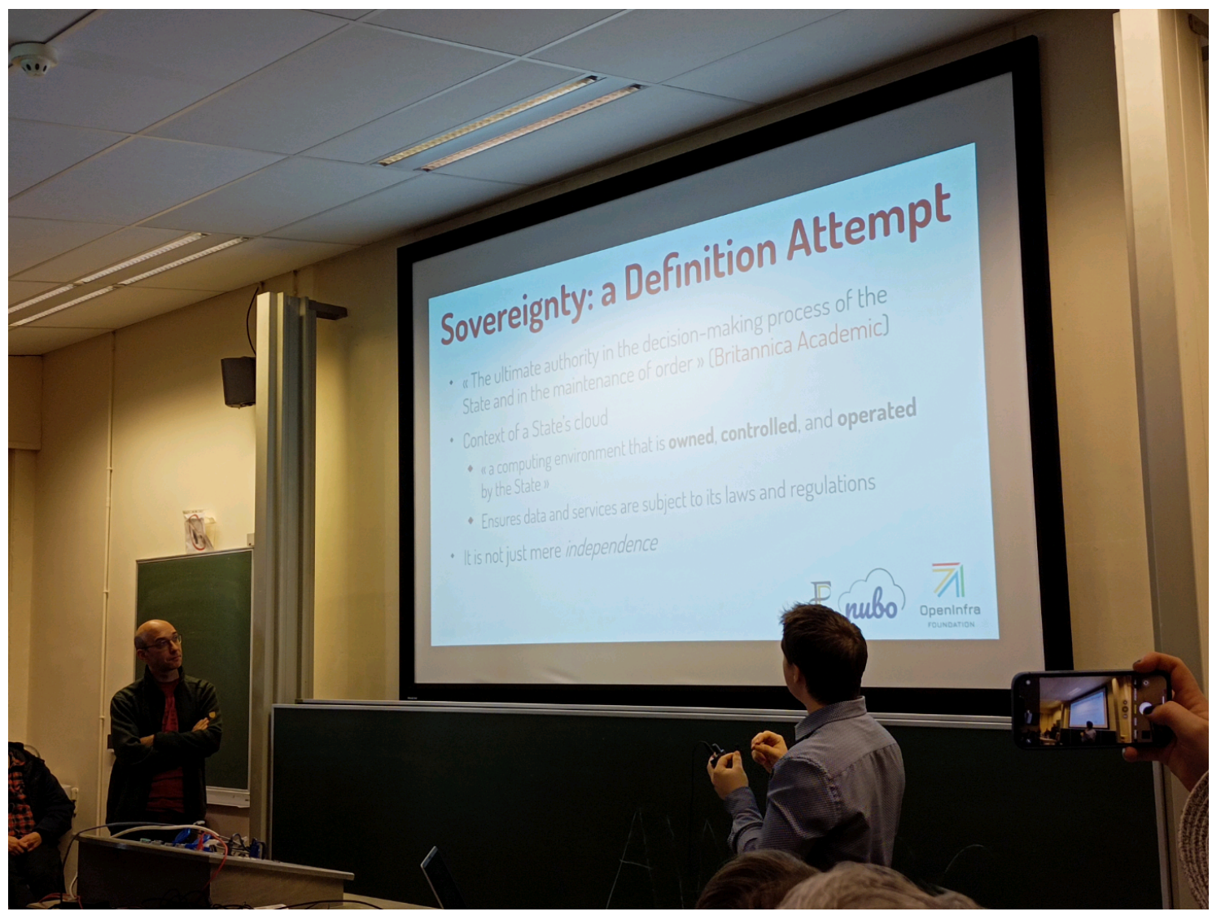

13h45 Fr cloud Nubo

OpenStack (15yo, used for public and private, around the world)

OpenInfra:

Need for local infrastructure

Why OS: avaibility transparency independence interoperability

Nubo: PIA, tooling & hosting, from 2016, exposed to internet & RIE, Kubo (kubernetes),

Free software: product vs project

bzg.fr/logiciel-produit-projet/

Sovereignty: owned controlled operated by the state

Q security/diffusion restreinte and using cloudp (?) A not yet for diffusion restreinte and working with cloudp

Q how manage many teams in the project A ministries

Q specific range and scope, how involve A incite to try and working in parallel

Q how explain to another ministry (outside Fr) to involve A no receipe, public aspose(?)

Q timeline for distribution A not yet

## [FOSDEM 2025 - Community Insights: Best Practices for Open Datasets for LLM training](https://fosdem.org/2025/schedule/event/fosdem-2025-6020-community-insights-best-practices-for-open-datasets-for-llm-training/)

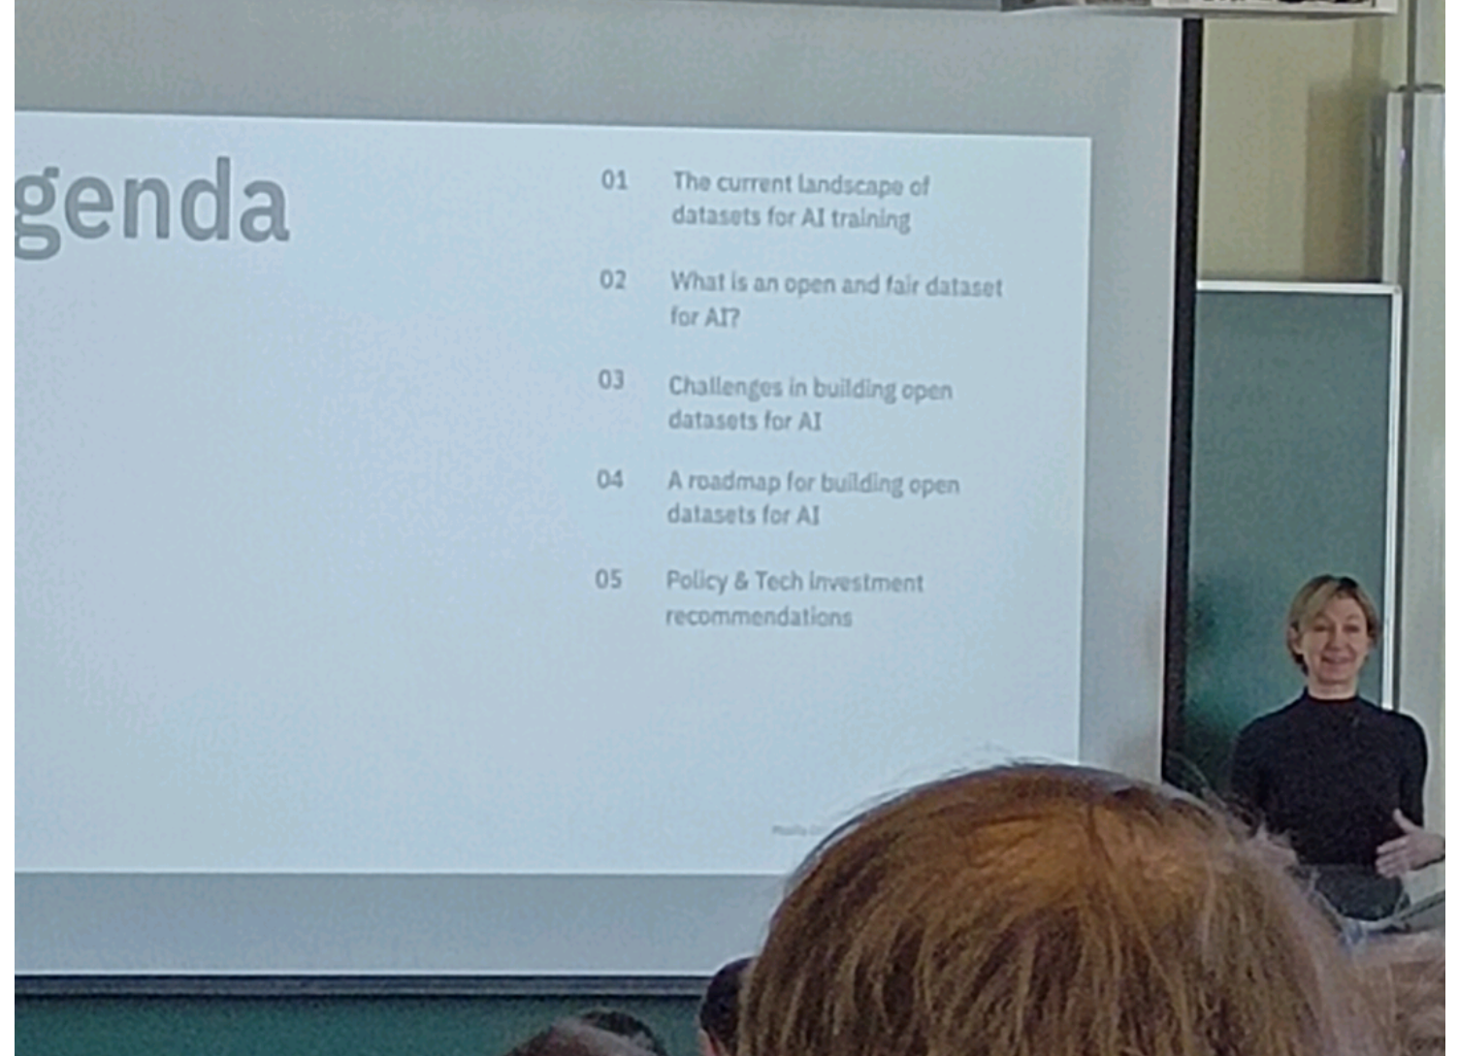

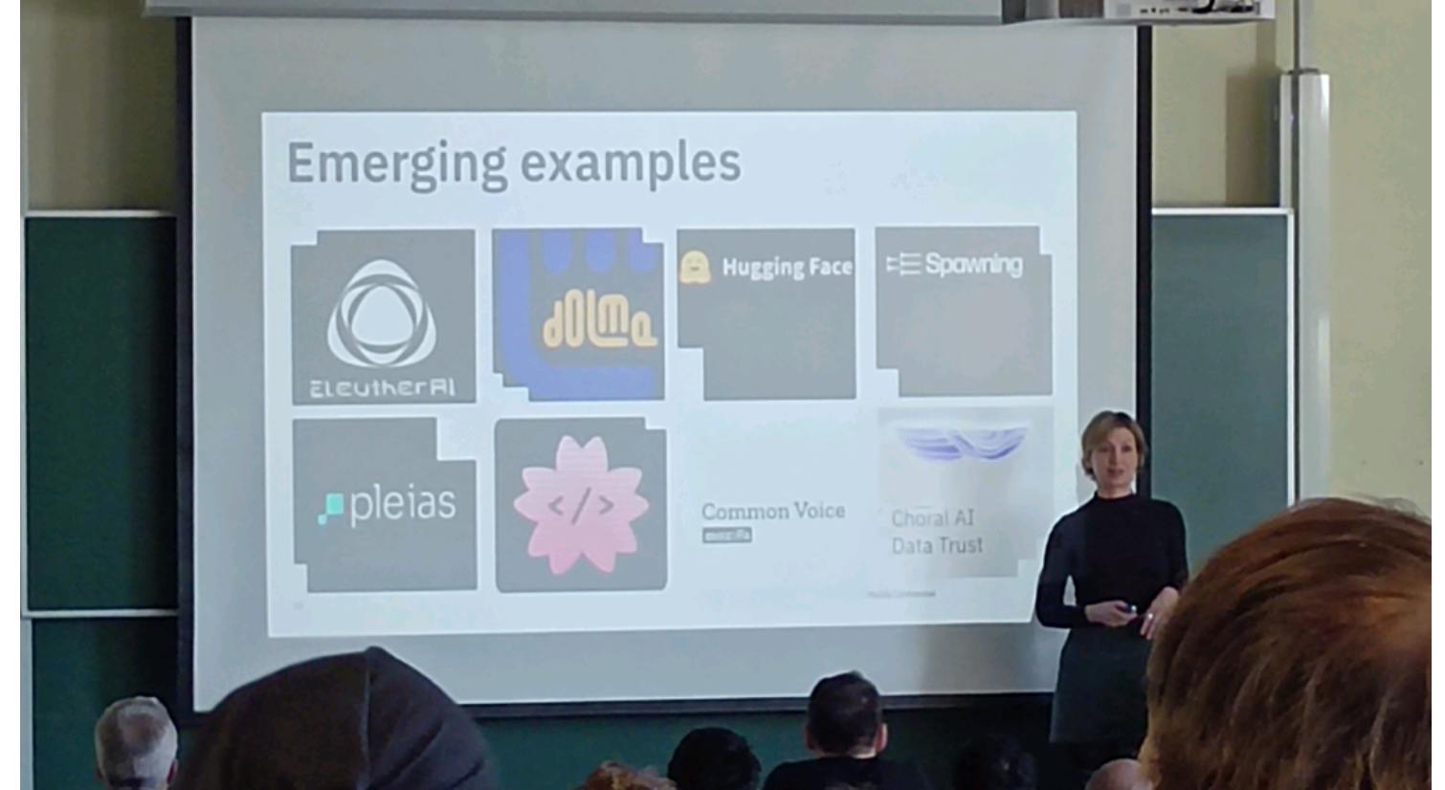

14h25 UB5.230 Mozilla B.P. llm training

Currently Dataset for training are no more released

Issue with copyright

Definition of open data / public domain

Even public domain content is not always easily digitalised

Research on going

## [FOSDEM 2025 - The Firefox AI Platform](https://fosdem.org/2025/schedule/event/fosdem-2025-4236-the-firefox-ai-platform/)

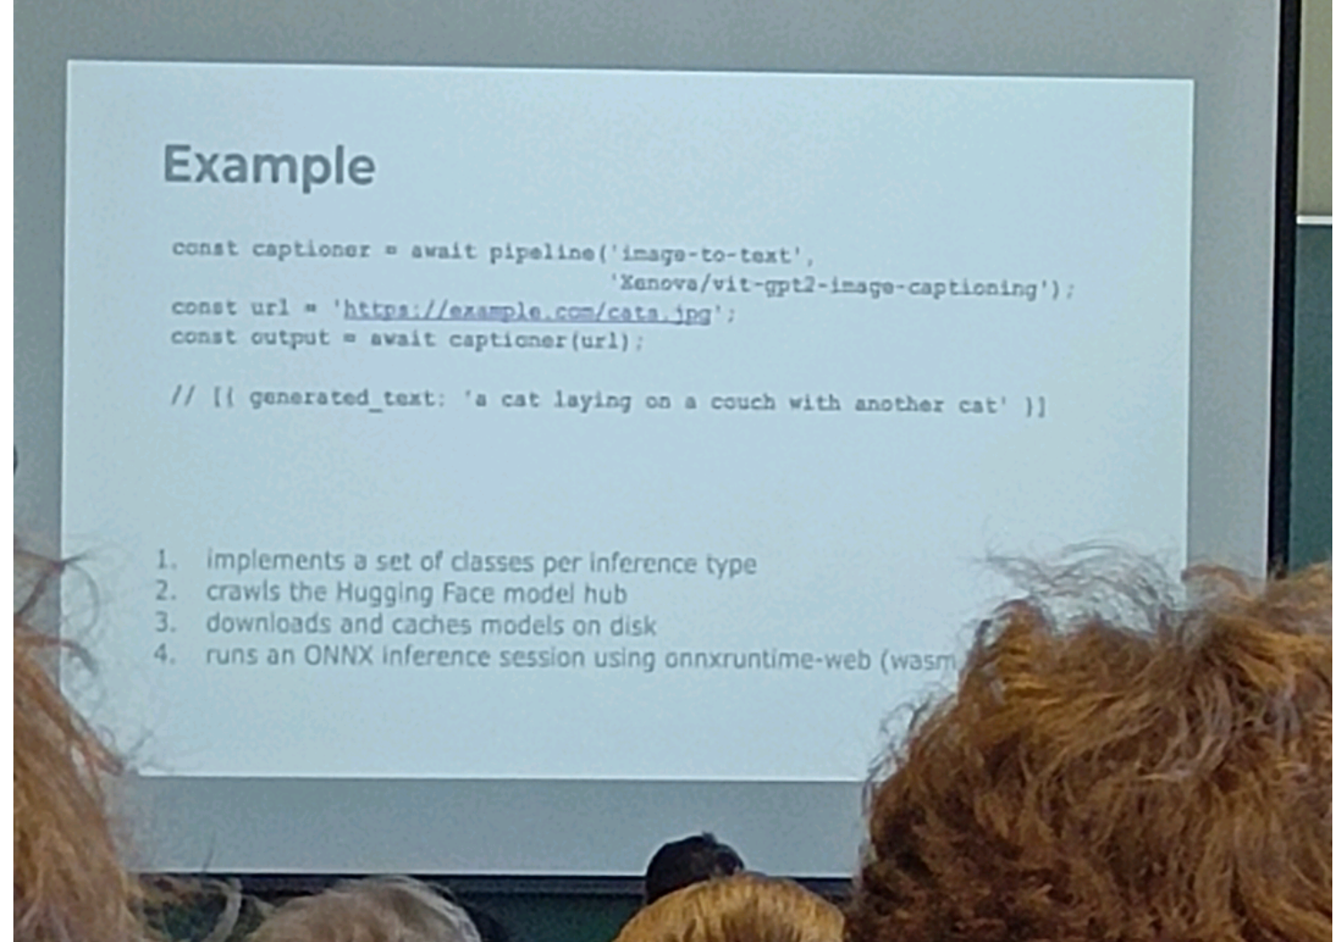

14h45 firefox AI runtime

* Translation since 2019 (based on bergamot)

New goals

* Image to text
* OCR (kind of)
* Text to speech and vice versa
* Etc

Bergamot won't be enough

Transformers.js (firefox 133+)

We extensions AI API (134)

<https://firefox-source-docs.mozilla.org/toolkit/components/ml/> Firefox AI Runtime

## [FOSDEM 2025 - The most fun you'll ever have dealing with Firefox crashes](https://fosdem.org/2025/schedule/event/fosdem-2025-6389-the-most-fun-you-ll-ever-have-dealing-with-firefox-crashes/)

15h00 firefox crashes

Capture crashes happening on end users with or without the users explicit the crash report sending

What happens? Immediate reload can be done and so invisible crash for the end user, prompt them to send report? Create confusion

Telemetry?

## [FOSDEM 2025 - What’s the (floating) Point of all these data types? A (not so) brief overview of the history and usage of datatypes within the wide world of computation](https://fosdem.org/2025/schedule/event/fosdem-2025-6537-what-s-the-floating-point-of-all-these-data-types-a-not-so-brief-overview-of-the-history-and-usage-of-datatypes-within-the-wide-world-of-computation/)

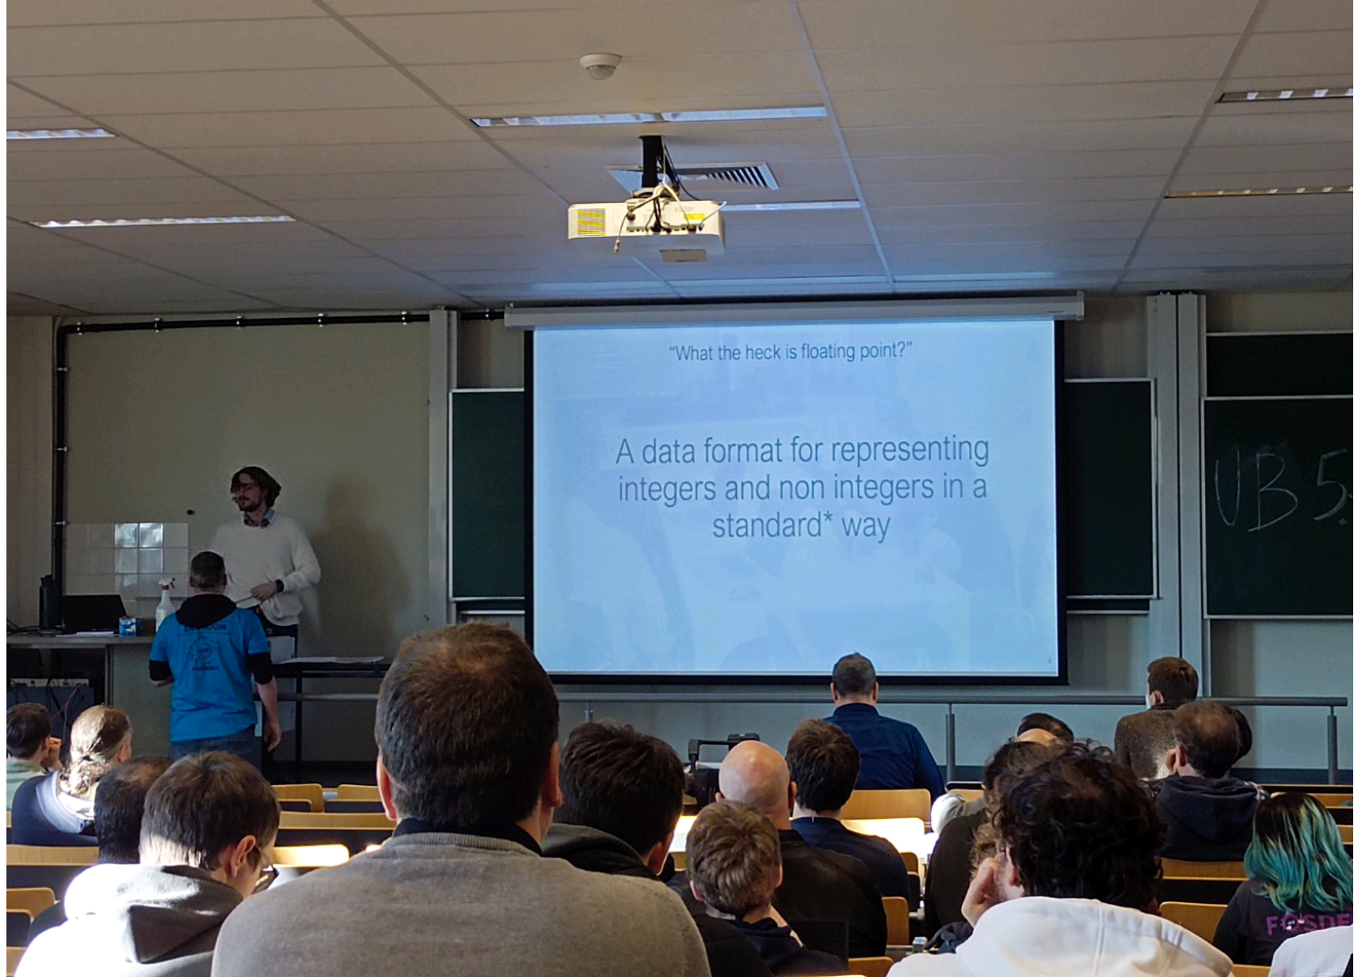

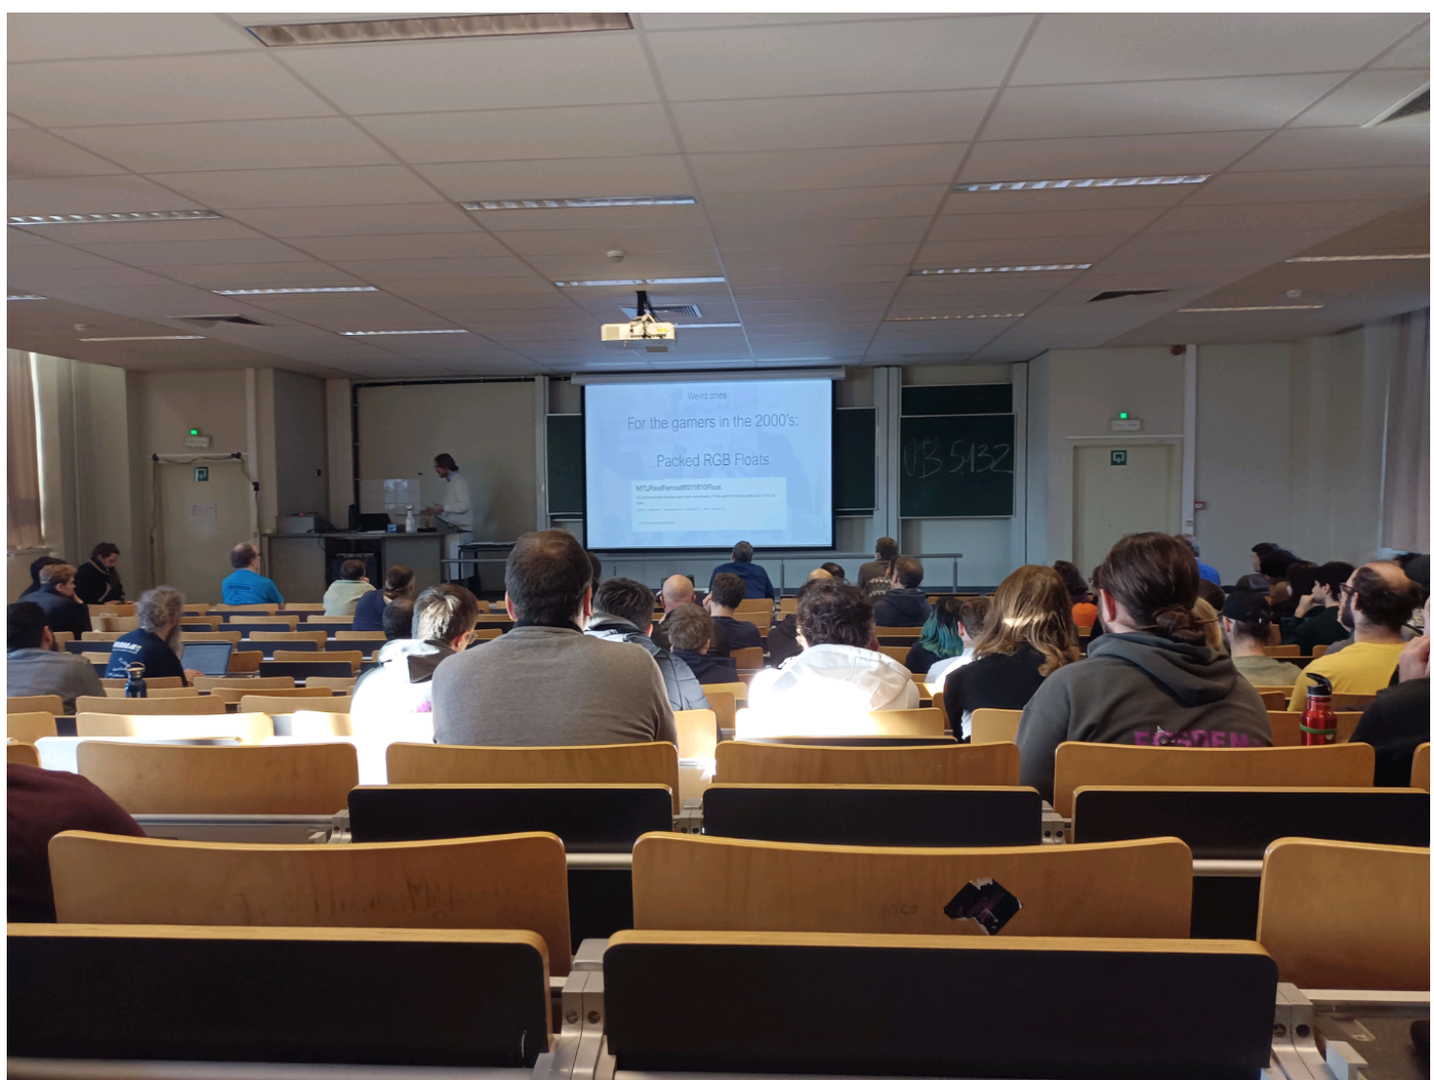

15h30 UB5.132 Datatype history kind of 'floating point'

Floating point: short version

Sign + Magnitude 3 Precision (fraction in magnitude)14 +3.14 (short ominous short explanation)

Medium version

Fixed point:

Base 10 how ?

Started from base 2

Binary floating point: (IEEE754 standard)

8087 support FP32 FP64 FP80

> Standard

Special type: (RGB) always positive

For memory optimization: 32bits

IEEE 754 2008 > FP16 32 64 128 256

FMA: fused multiply add, avoiding rounding too much

Brain float, FP8, …

Truncate format from FP32 to FP16, when the precision is less needed for optimisation

TF32 combine BF and FP ?